

**INTERNATIONAL PROGRAMMES**

**BSc Computing and Information Systems**

**Name: Muhammad Taqiuddin Bin Mohamed Zaini**

**a)**

**1. ULights (Smart lighting system for home)**

**Core functionalities**

Control lights in the home using mobile app. Able to be fixed into regular light fittings. No additional wirings required. Voice activation to turn on/off. Comes with an app so that user is able to control the lights in the home from anywhere.

**Additional functionalities**

Able to set timing intervals for the on/off of the lights. Able to adjust brightness and colour of lights.

**2. UVac (Robot vacuum cleaner)**

**Core functionalities**

Robot vacuum cleaner that vacuums the house automatically with minimal human intervention required. Able to navigate around the house and suck up dust, crumbs etc. Comes with an app so that user is able to control the vacuum from anywhere.

**Additional functionalities**

App is able to schedule cleaning times. Stops vacuuming and automatically goes and attaches itself to its charging dock for charging. Able to clean for 4 hours with a 90 minute charge. Notifies when its dust bag is full by sounding a beep.

**b)**

**User Profiles**

**The two mobile apps mentioned above will be designed with the following user profiles in mind:**

1. An elderly retiree looking for a more convenient way to accomplish daily tasks.
2. A young student looking to be more productive and efficient.
3. A working adult looking to be more organised and enjoy life.

**Persona**

**1.**

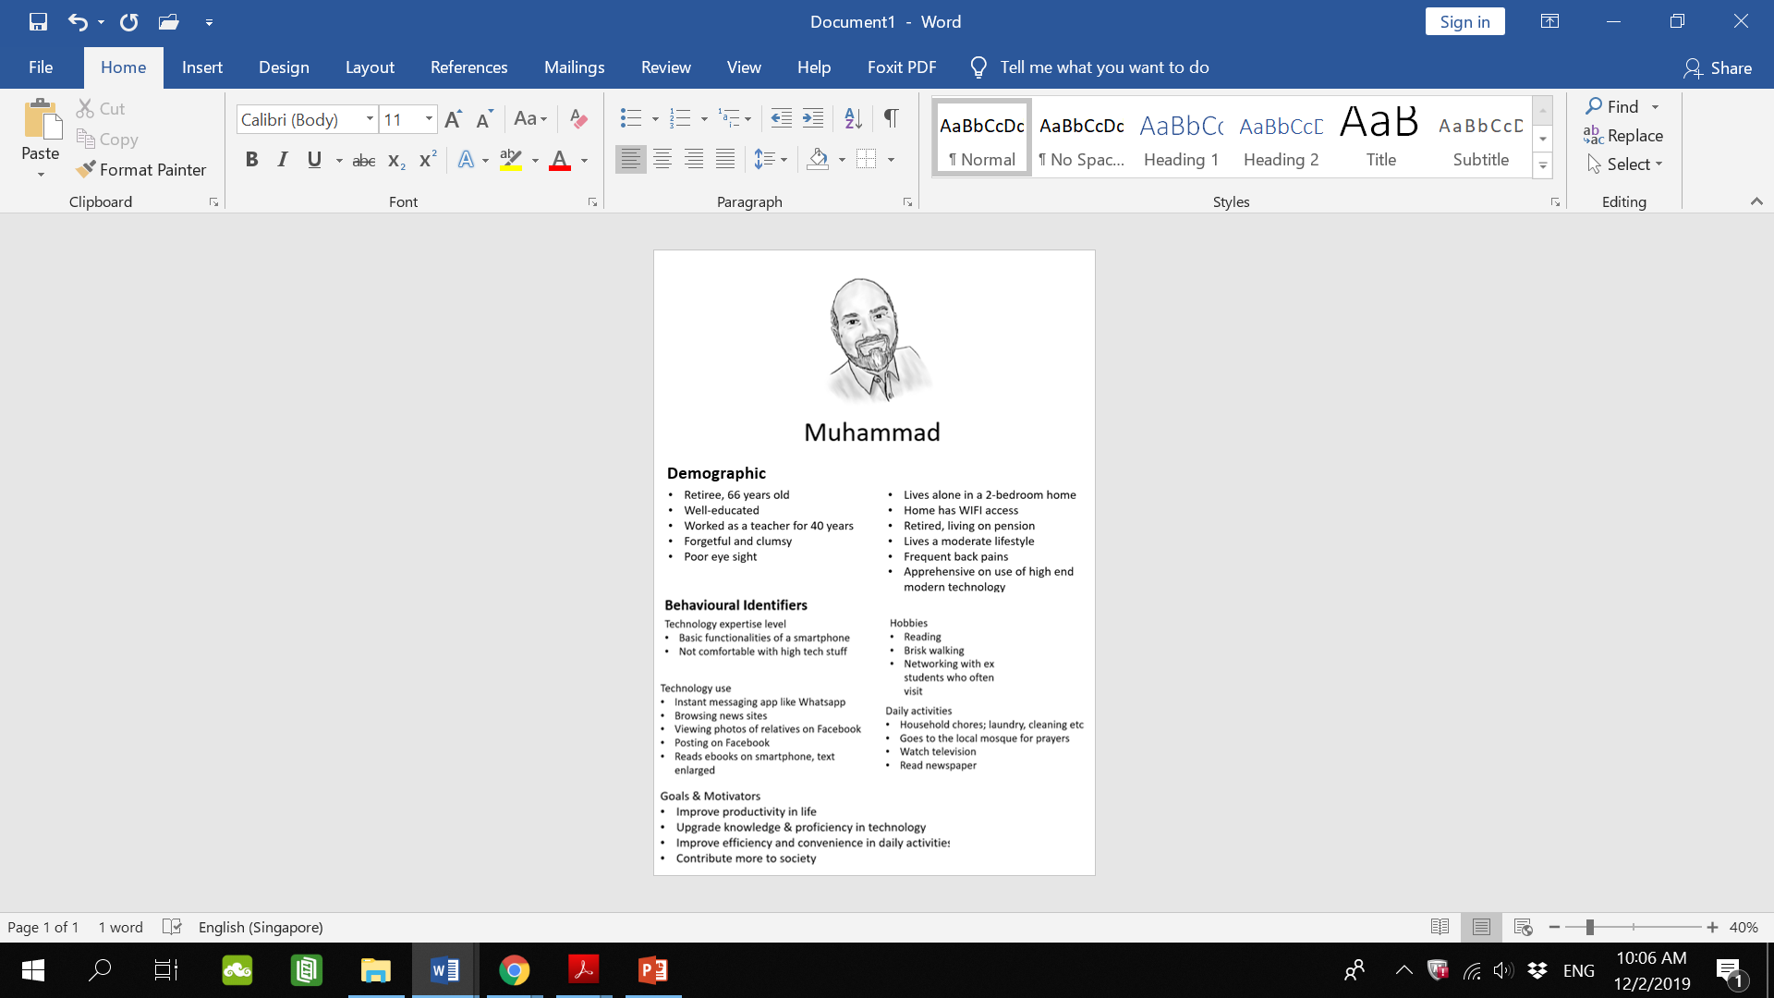

**2.**

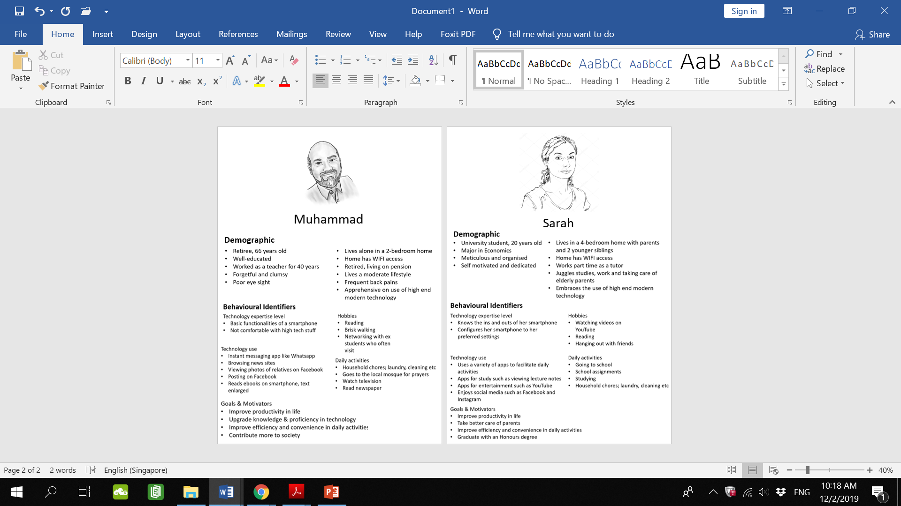

**3.**

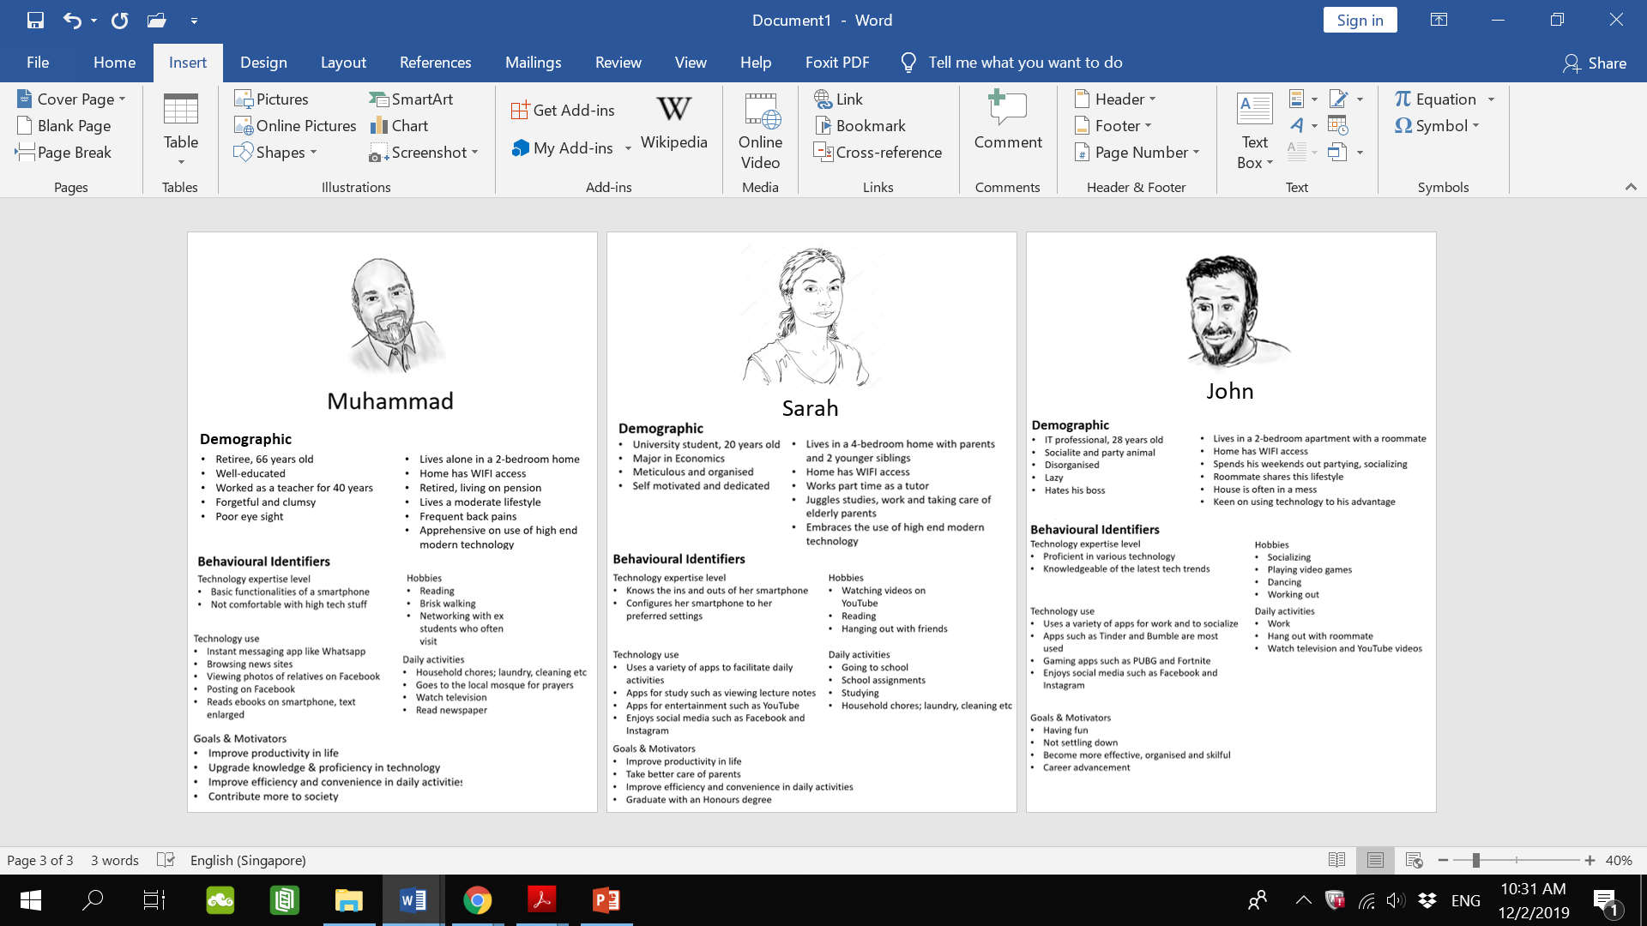

**c)**

**User Scenarios**



**User No. 1: Muhammad**

**Goal: Muhammad wants to have more convenience in cleaning the house and reduce energy consumption in his home.**

**Motivator: Does not want to aggravate his back pains. Always forgets to turn off the lights when leaving the house and wants to save money on electric bill.**

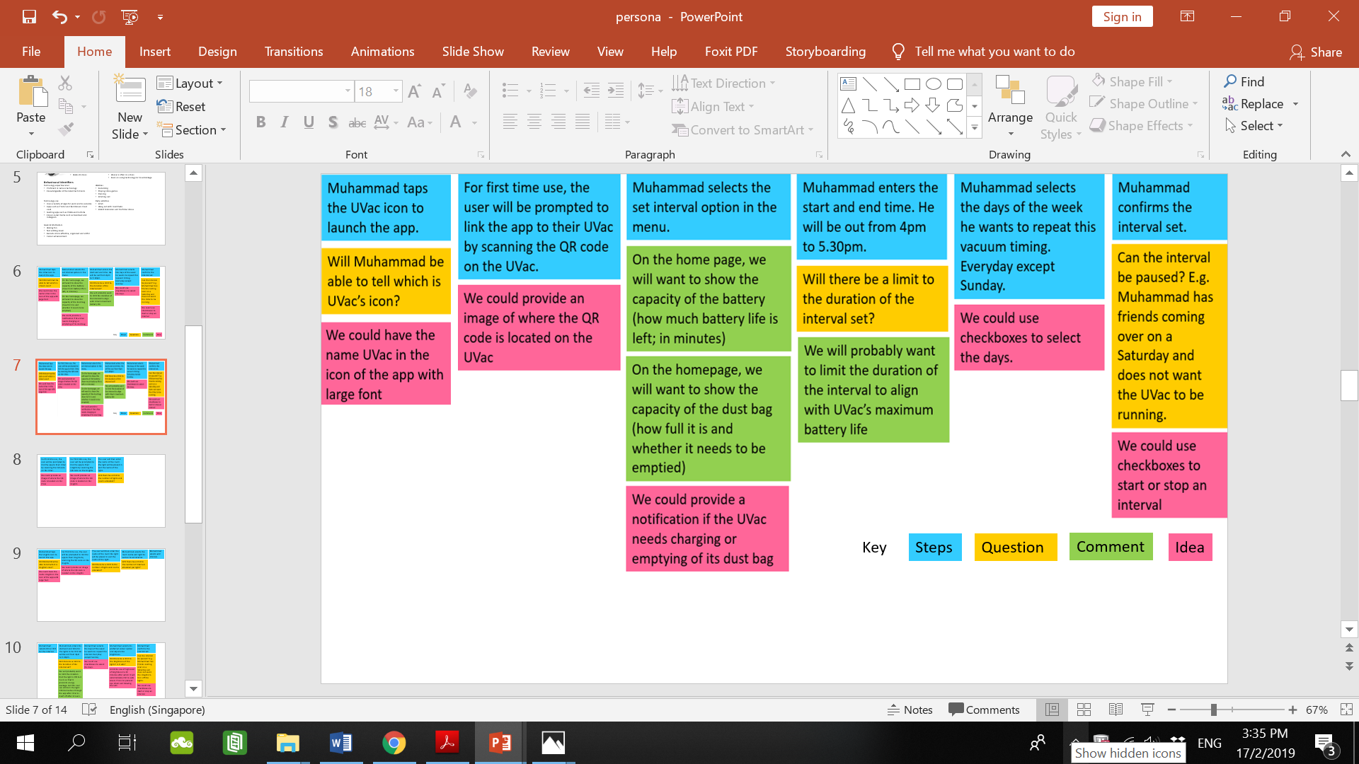**Activity 1 (UVac): Vacuum the home while he is out.**



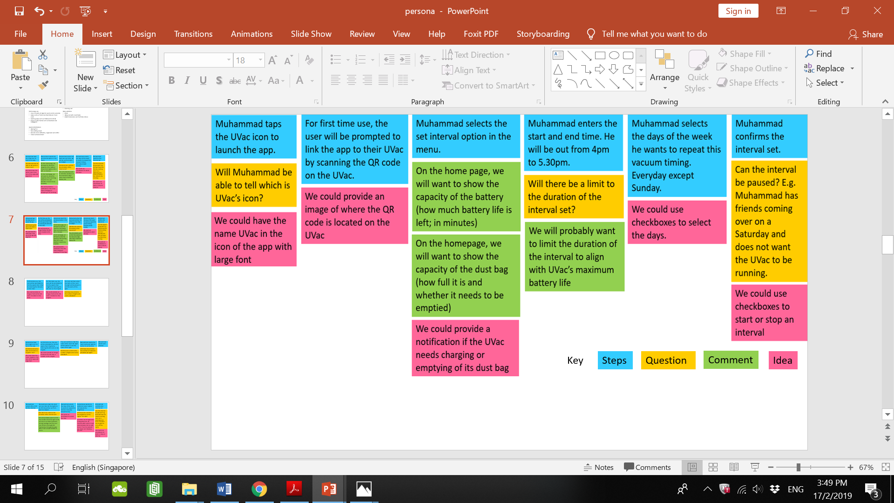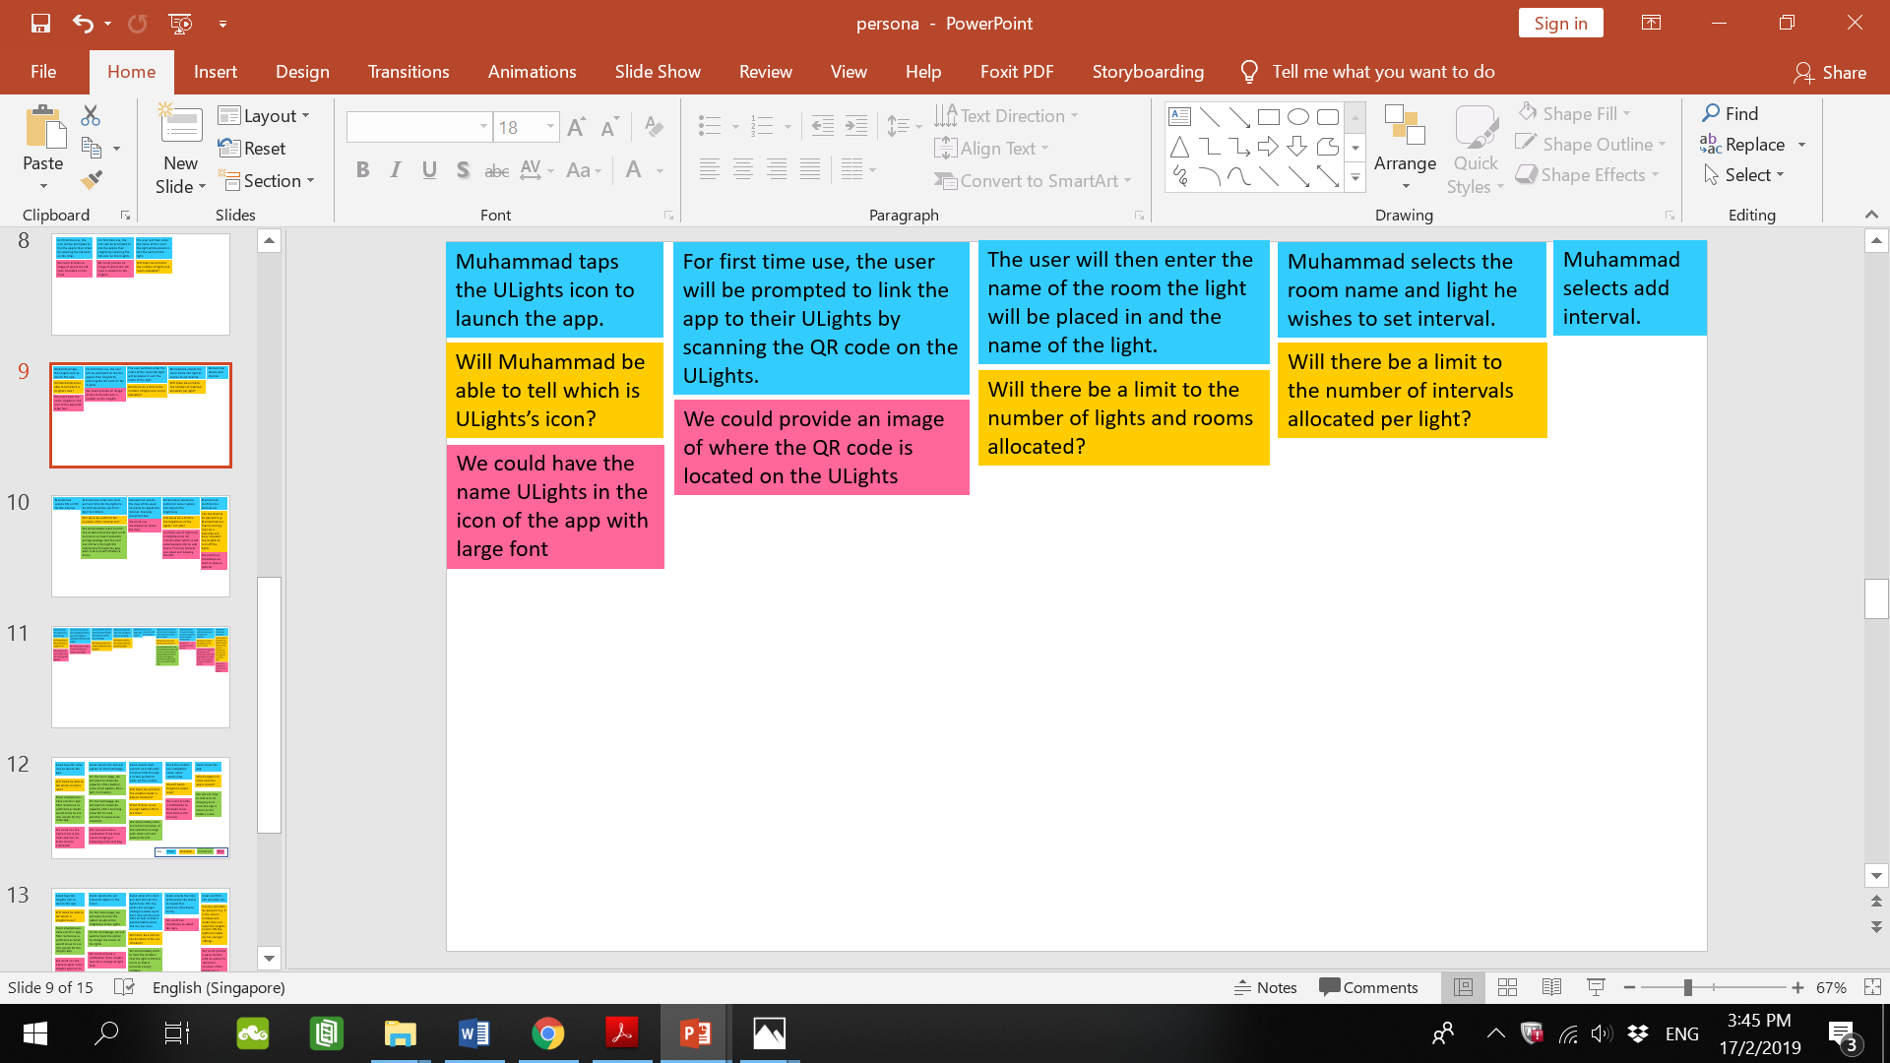**Activity 2 (ULights): Set the lights to turn off when he is not in the house.**

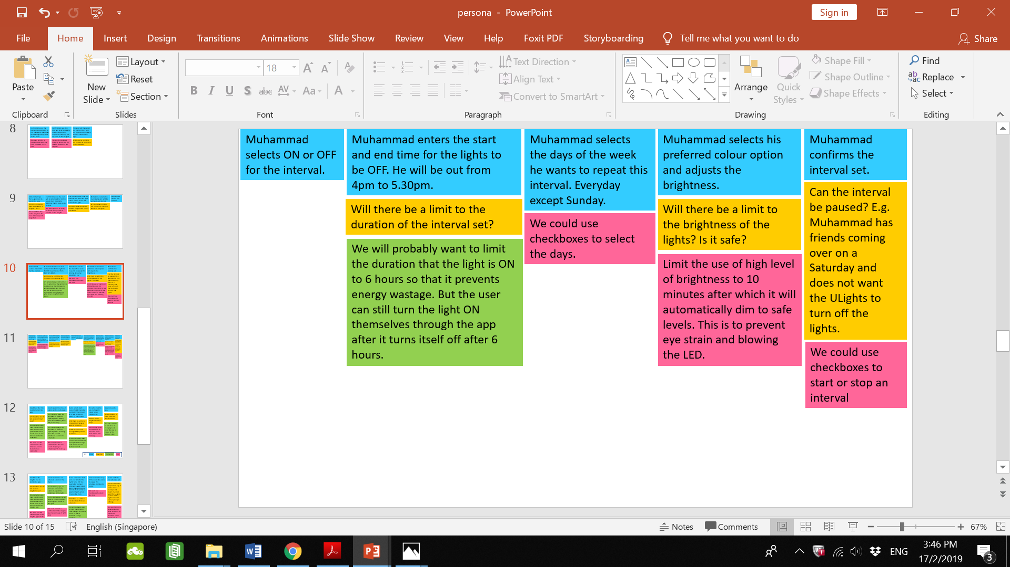**Continued ->**





**User No. 2: Sarah**

**Goal: Sarah wants to be more productive in taking care of her parents and siblings while studying.**

**Motivator: Take better care of her family, study better, graduate with an honour’s degree.**

**Activity 1 (UVac): While studying, she wants to be efficient in cleaning up for her younger siblings who left a lot of bread crumbs after eating.**

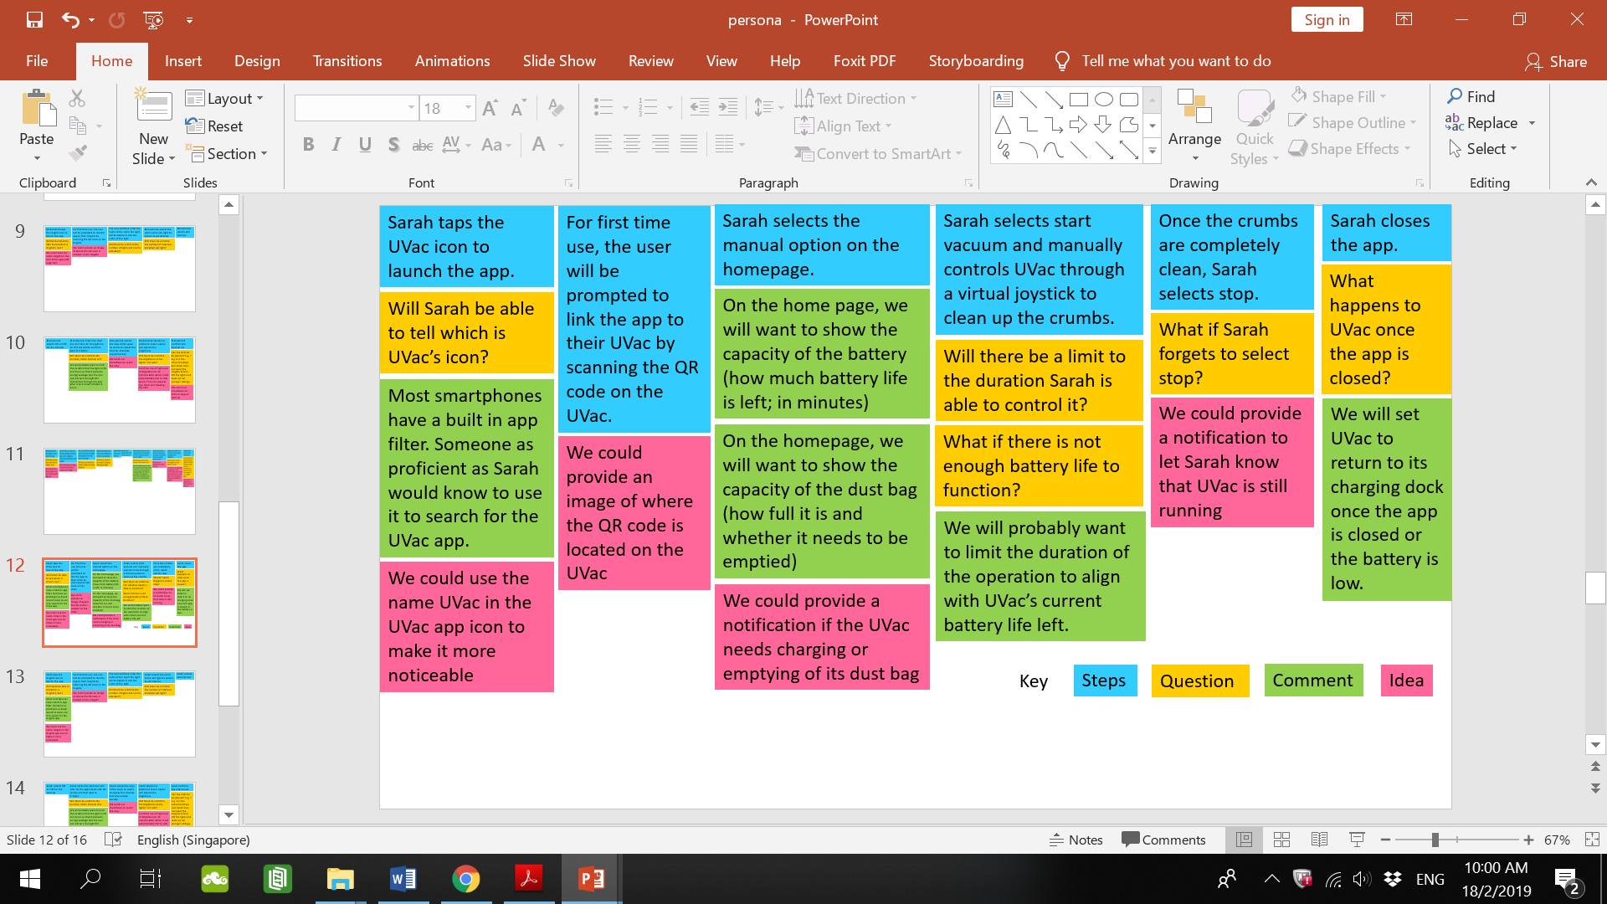



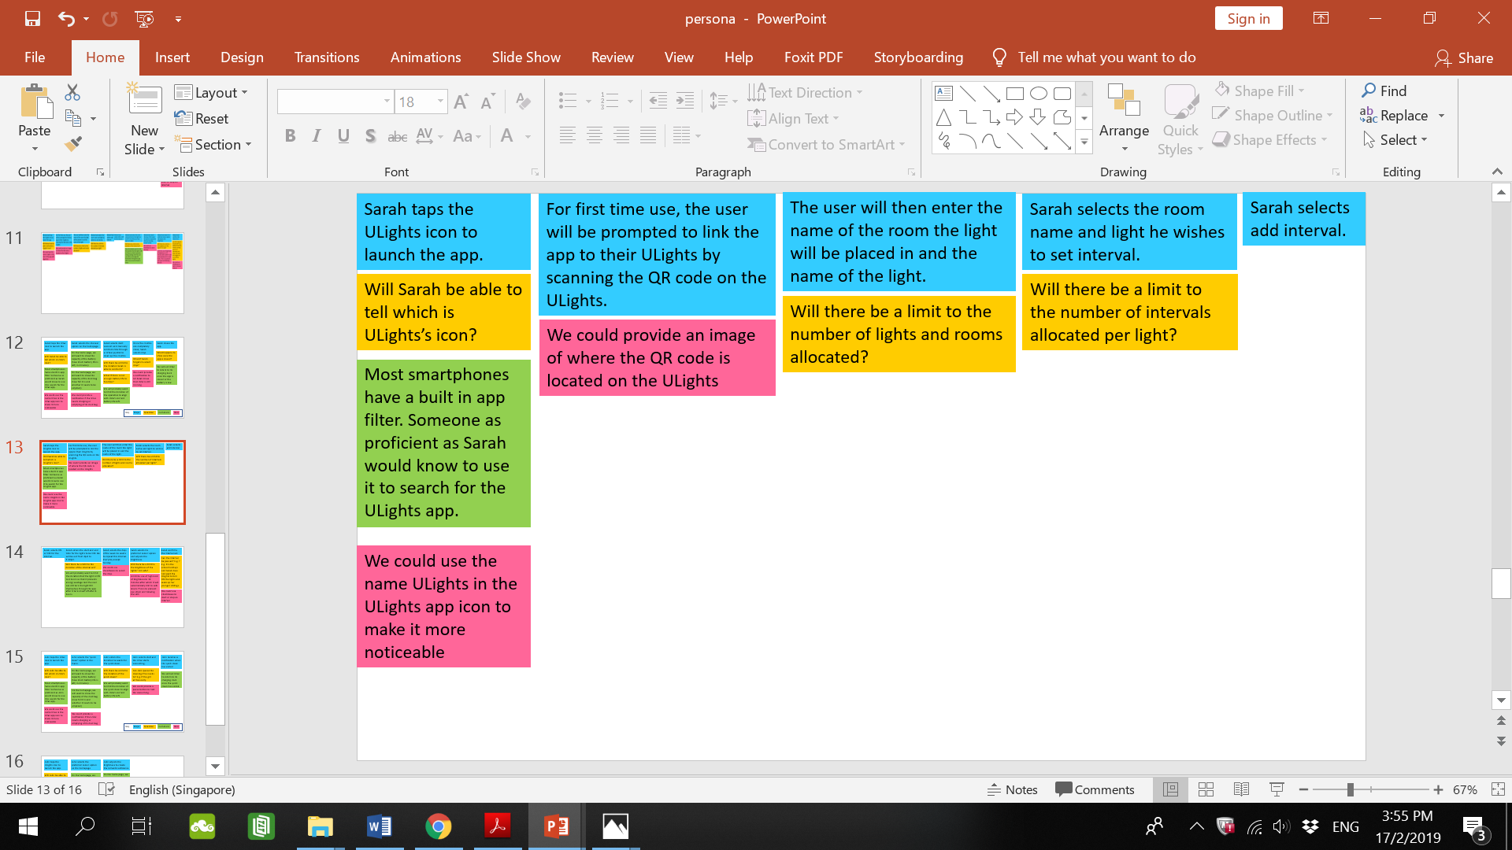**Activity 2 (ULights): Sarah wants to set the lights to turn ON in the morning so as to wake her younger siblings up for school.**



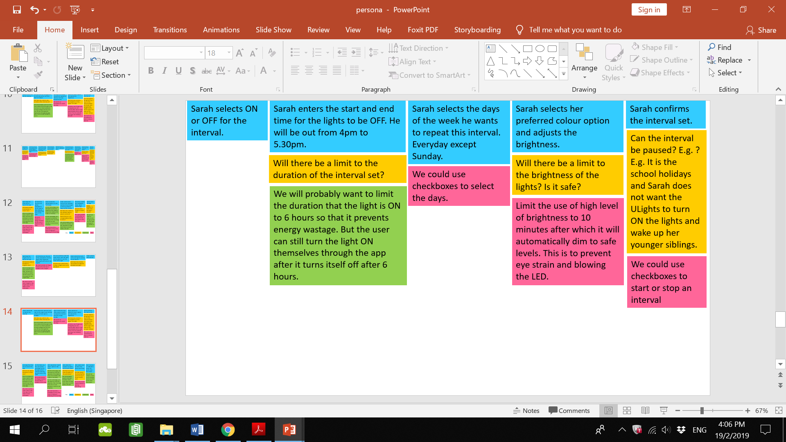**Continued ->**





**User No. 3: John**

**Goal: John wants to impress a girl who is coming over to his place for a romantic dinner**

**Motivator: Have a good time.**

**Activity 1 (UVac): John wants clean up the place quickly.**

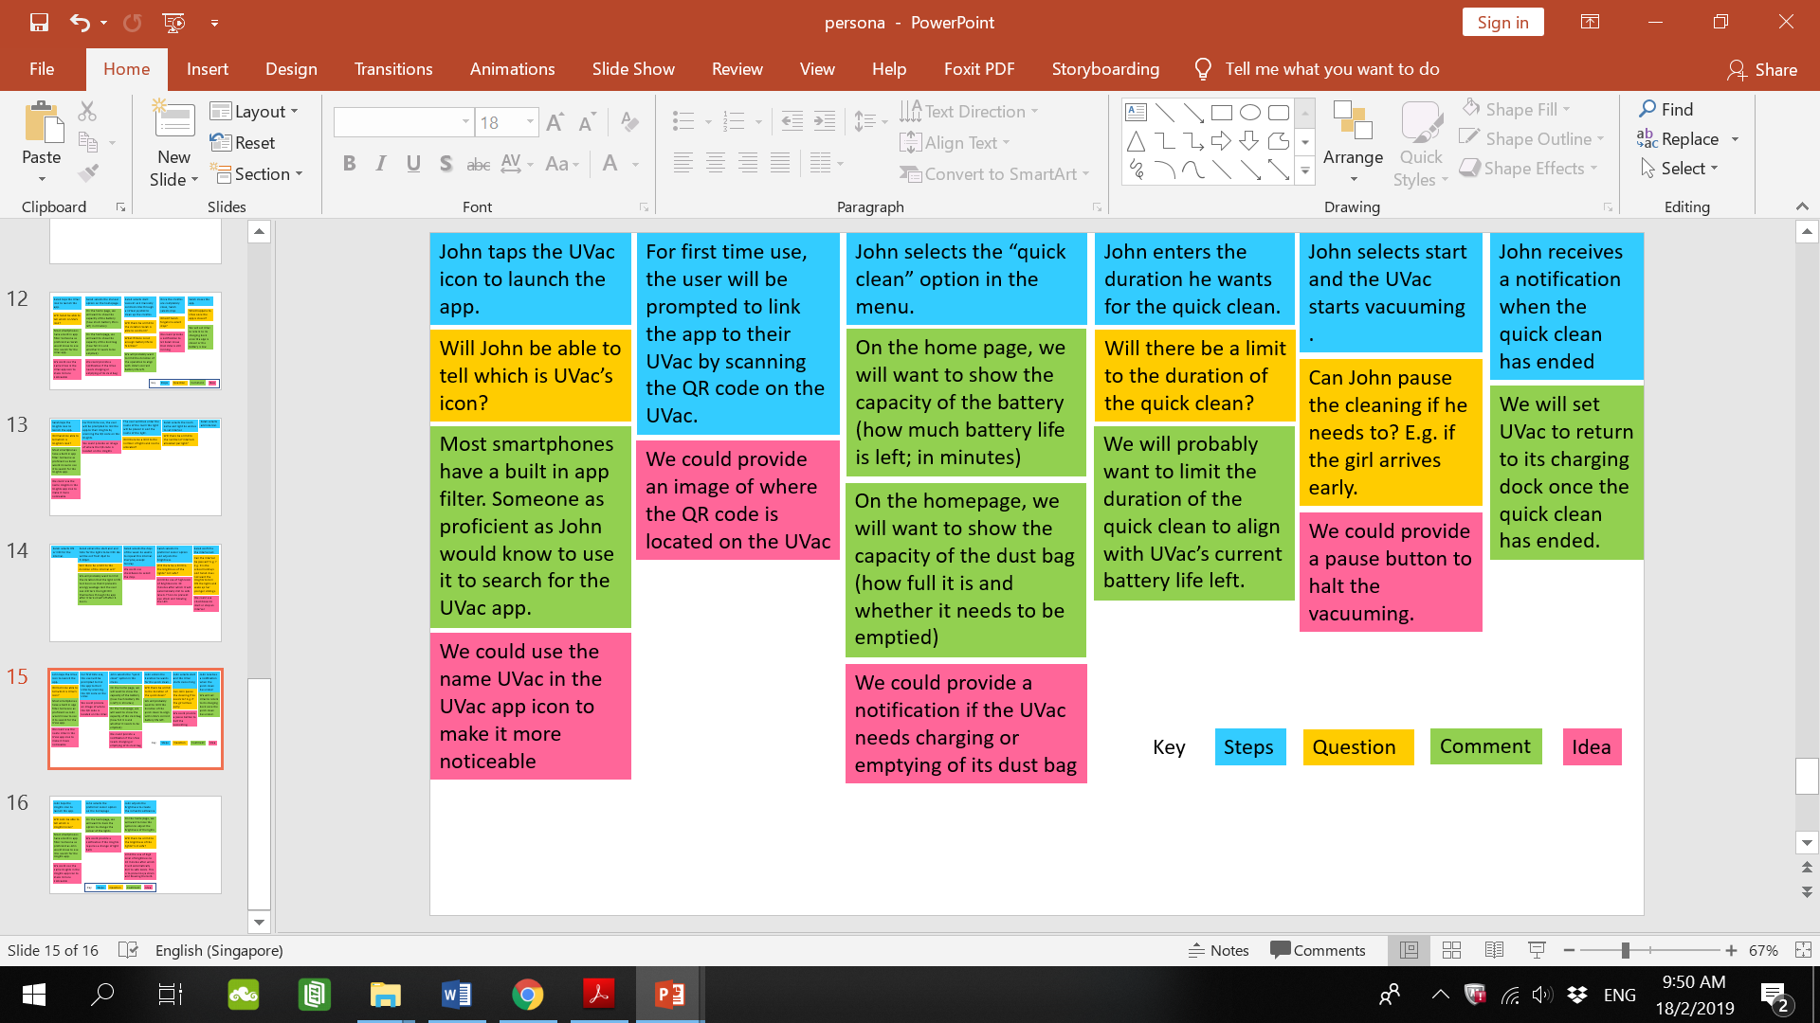



**Activity 2 (ULights): John wants to set the colour and intensity of ULights to create a romantic ambience.**

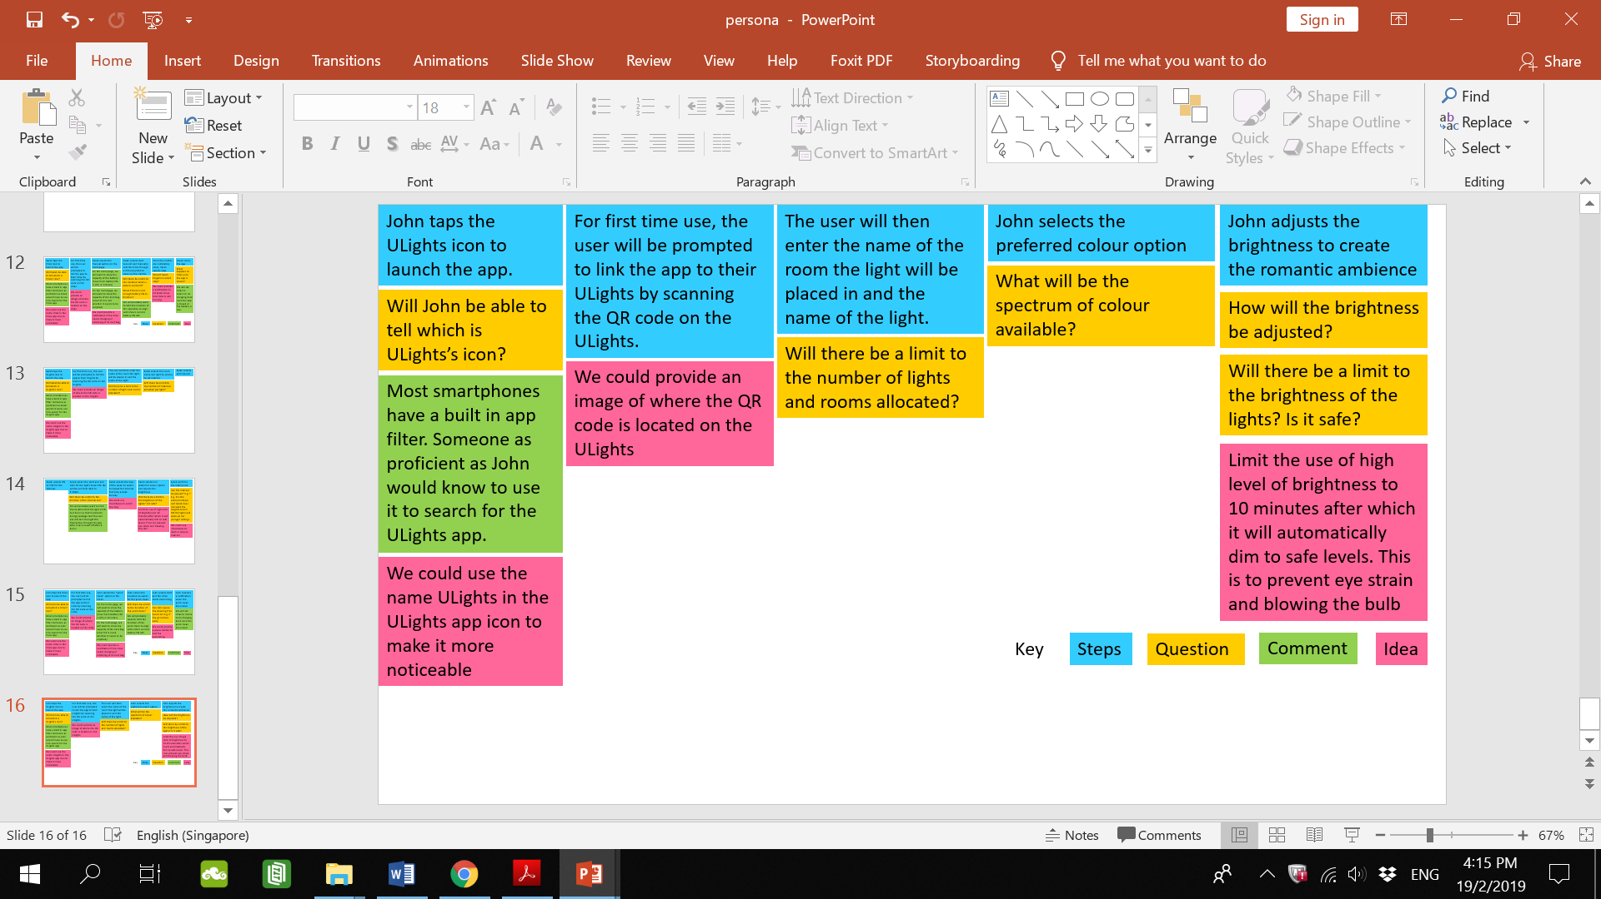

**Design mock up**

**UVac**

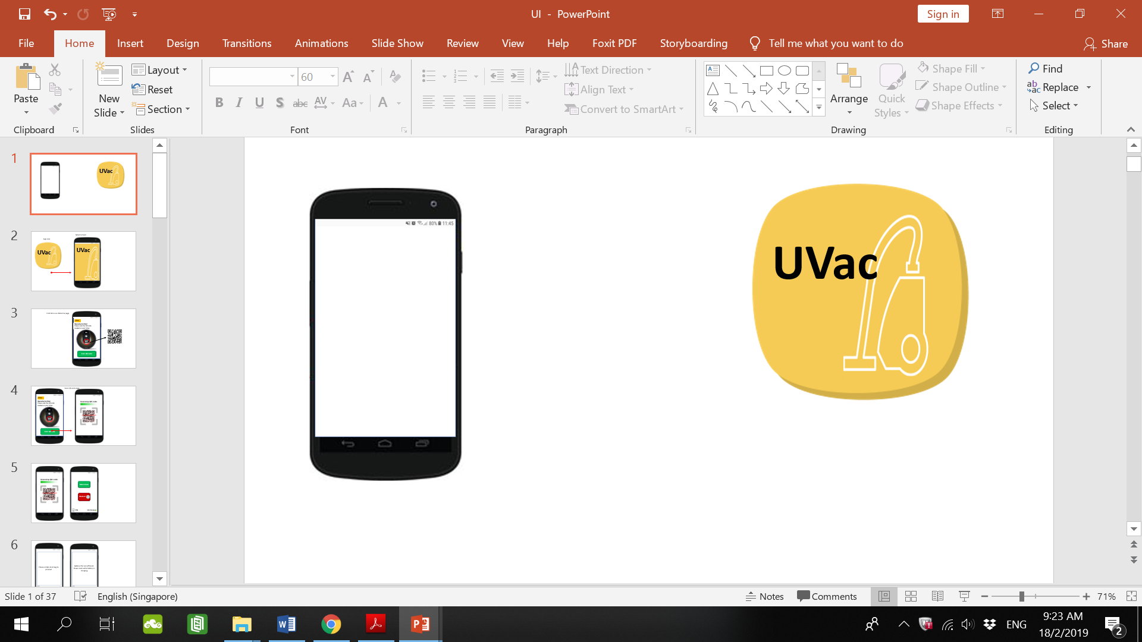

**Justification & Critique:**

UVac’s app icon has the app name in relatively large font. This would make it easy for Muhammad to identify it instantly.

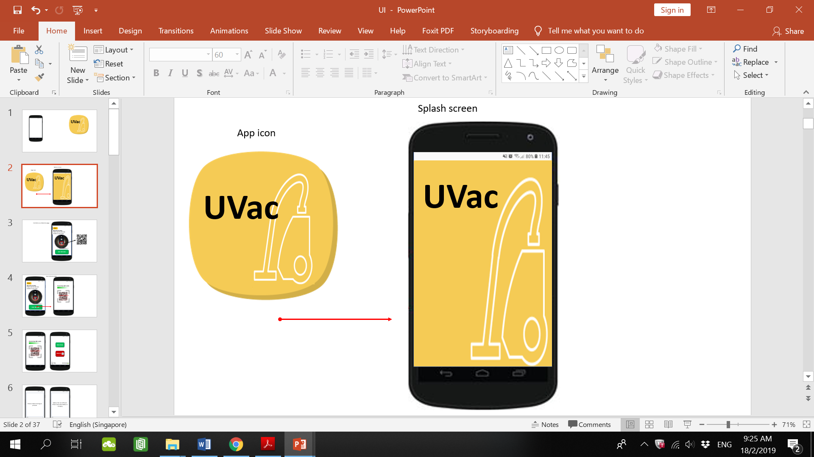

**Justification & Critique:**

Upon selecting the app, the app launches and this splash screen appears. Also called a load screen, it does not have any functional elements. Splash screen is a good way of letting users know that the app is in the process of starting and has not crashed upon launch. This is in line with the Usability Heuristic of Visibility of System Status. The user is kept informed of what is going on.

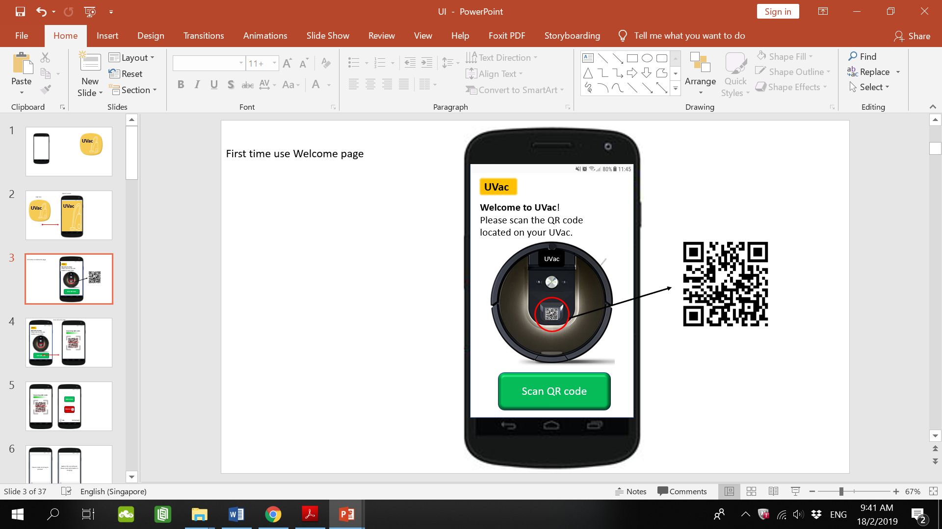

**Justification & Critique:**

For the first time use the user will be prompted to scan the QR code on their UVac to link it to the app. An image shows where the QR code is located and there is a button to start the scan. This makes it clear to the user on what to do. The user does not have to search too long for the QR code on their UVac.

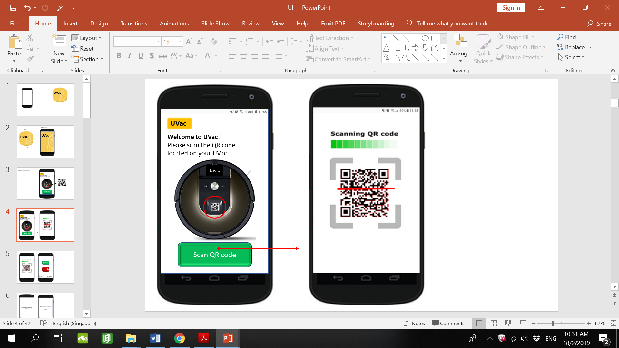

**Justification & Critique:**

The “Scan QR code” button makes an indentation when selected showing that it has been selected (left). There is a loading bar when scanning the QR code (right). These are in line with the Usability Heuristic of Visibility of System Status.

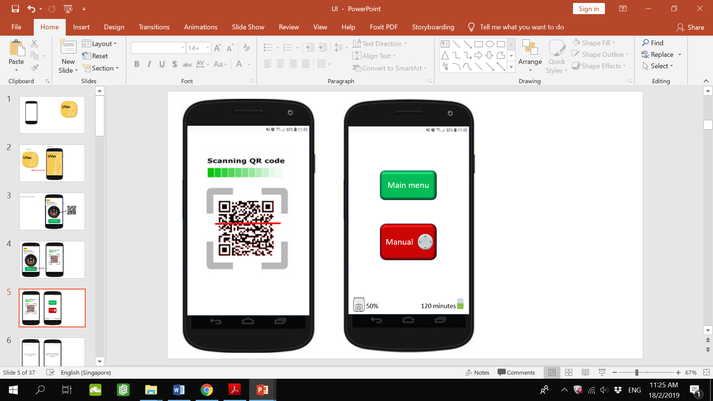

**Justification & Critique:**

This is the homepage of the app. On the bottom left there is an indication of how full the UVac’s dust bag is. In this example, the dust bag is 50% full. On the bottom right there is an indication of the battery life of the UVac. In this case, the UVac can be used for 120 minutes before running out of battery. This is in line with the Usability Heuristic of Visibility of System Status. There are 2 buttons. One to access the main menu and one to access manual remote control for the UVac. The buttons are relatively big. Muhammad would appreciate this as it would not require much precision to select it as compared to if the buttons were really small. However, younger users such as Sarah and John might find the appearance of huge buttons unsightly and old-fashioned. Its simplistic design is in line with the Usability Heuristic of Aesthetic and minimalist design.

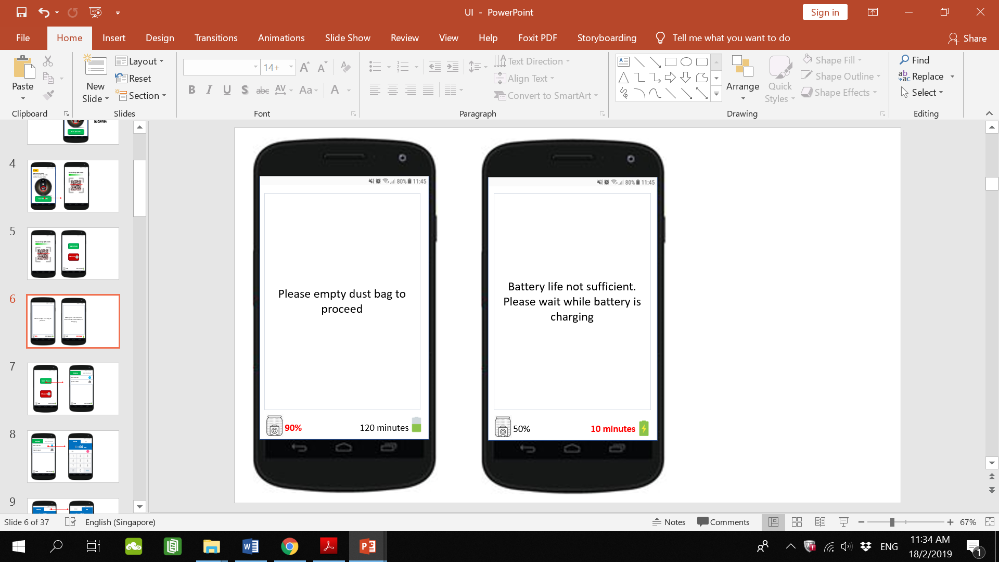

**Justification & Critique:**

In the event that the UVac’s dust bag almost full, the app will notify the user and prevent the user from using the app as shown above. This constraint is so that the user will commit the error of overloading the dust bag. This is in line with the Usability Heuristic of Error prevention. Font is big so that Muhammad will be able to read it. This keeps the user informed of the status of the system so that the user knows what to do.

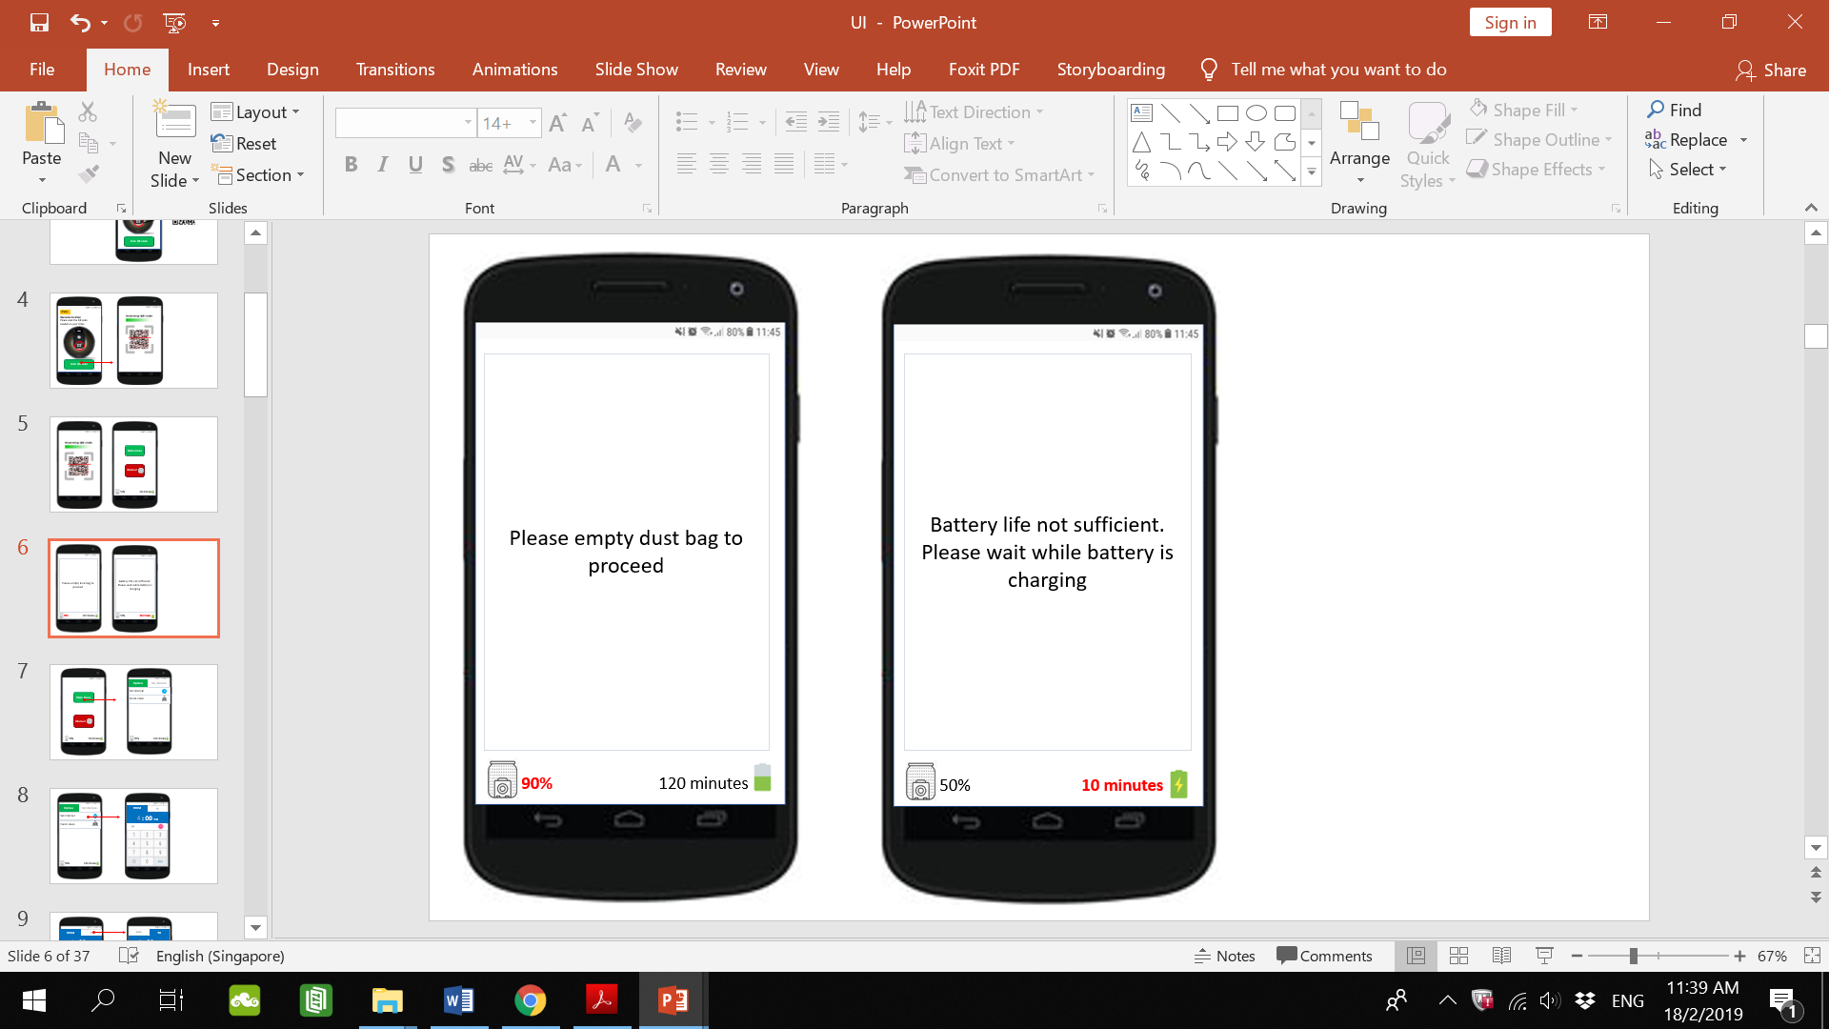

**Justification & Critique:**

In the event that the UVac’s battery is low, the UVac will automatically return to its charging dock and the above message will appear on the app to notify the user. Font is big so that Muhammad will be able to read it. This keeps the user informed of the status of the system so that the user knows what to do.

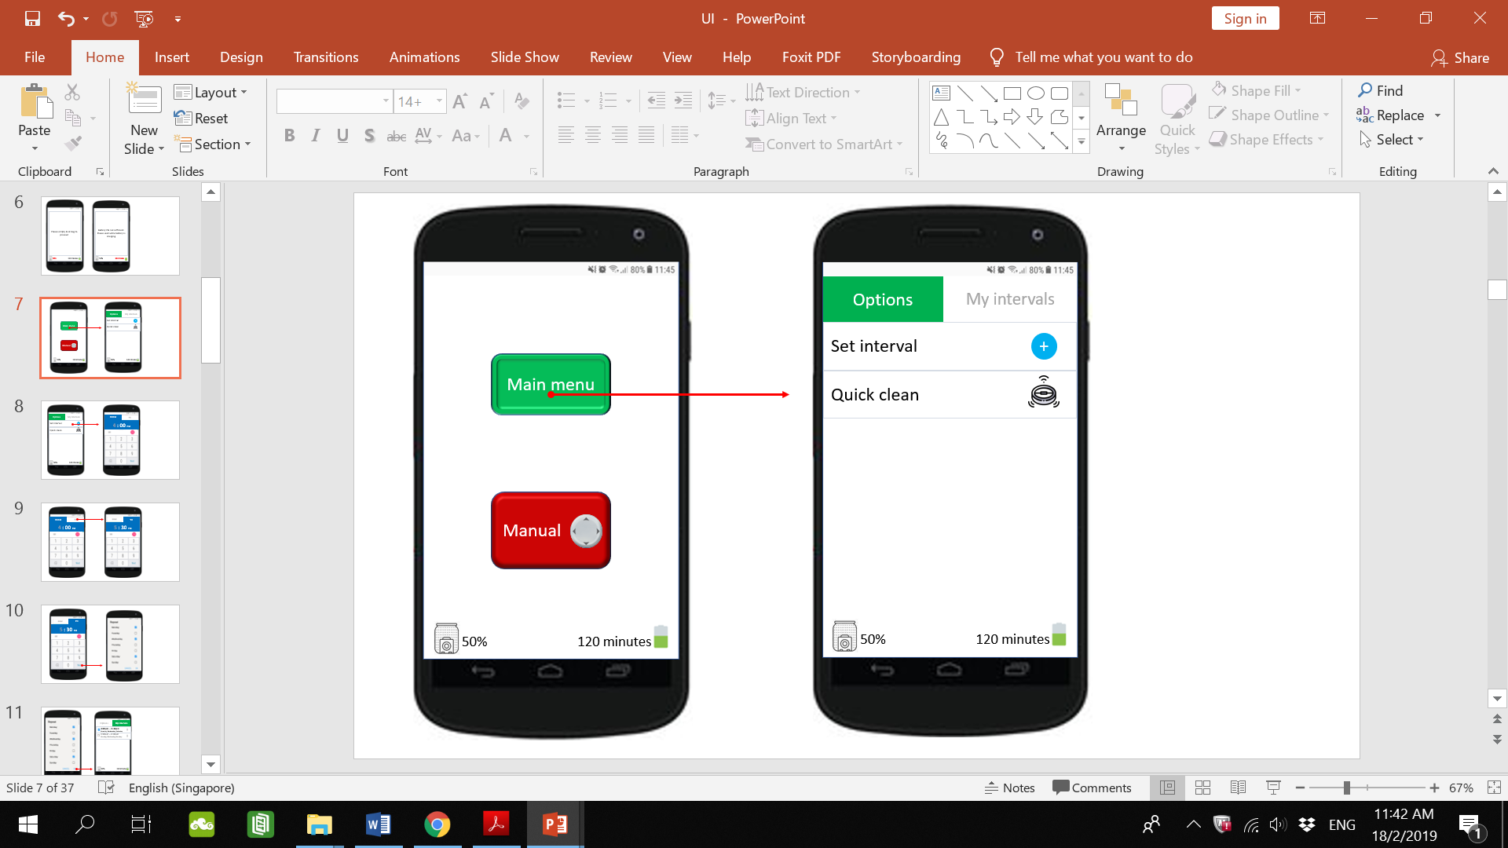

**Justification & Critique:**

Upon selecting the main menu button (left), the user will be directed to main menu page (right). It consists of two tabs. Options and My intervals. Tab selected is coloured so as to make it more conspicuous. The default tab when main menu is selected is Options. The Options tab has two options that allow the user to set an interval or start a quick clean. The Set interval and Quick clean buttons are as wide as the screen. Muhammad would appreciate this as it is not a small button that requires much precision to select. The dust bag and battery life indication on the bottom of the page keeps the user informed.

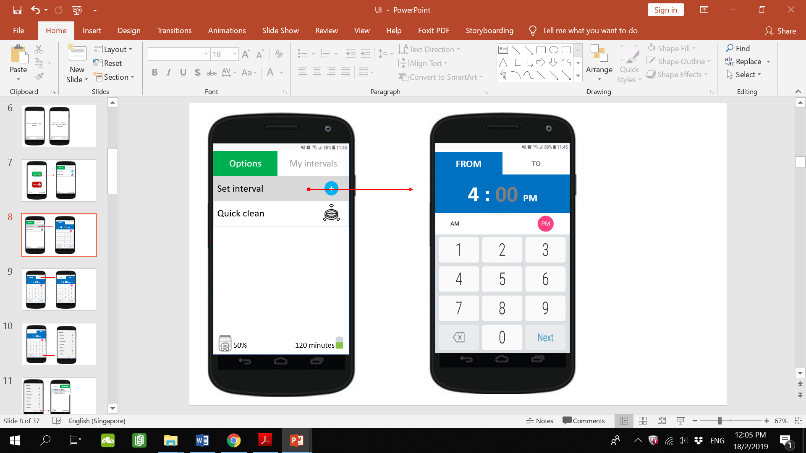

**Justification & Critique:**

Upon selecting Set interval (left), the button changes colour to indicate that it has been selected. The user will be directed to the set timing page (right). It consists of two tabs; From and To. The tab buttons are relatively big so that they can be easily selected. In the From tab, the user enters the time to start the interval. In the To tab, the user enters the time to end the interval. The keypad for entering numbers have big buttons for the numbers so that they can be easily selected. It also contains a backspace button on the bottom left for the user to delete in case the wrong number is entered. This is in line with the Usability heuristic of User control and freedom due to having an undo function. In line with the Usability Heuristic of Match between system and the real world, 12-hour clock format is used as seen by the AM or PM selector. This is because this format is more widely used and understood. The selected option (PM) will be highlighted with a pink circle to show that it is the selected option.

In this instance, the hour number (4) is in white indicating that the user is currently entering the hour portion of the time.

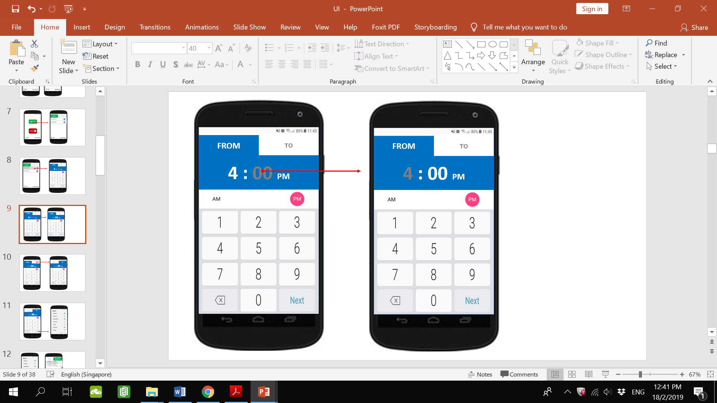

**Justification & Critique:**

When the user selects the minutes part of the time (left), those numbers will turn white (right) indicating that the use is currently entering the minutes of the time. Note that it is not necessary for the user to select the minutes part as after the hour part has been entered, the system will go on to the minutes part (minutes numbers will turn white). This is just to illustrate that both hours and minutes part can be selected in case adjustments need to be made.

In line with the Usability Heuristic of Preventing User Errors, constraints will be used on how the user sets the time. For example, 39:78 PM makes no sense hence there is a potential for error here. Therefore, the hours will have a range constraint from 1 to 12 and minutes will have a range constraint from 0 to 59.

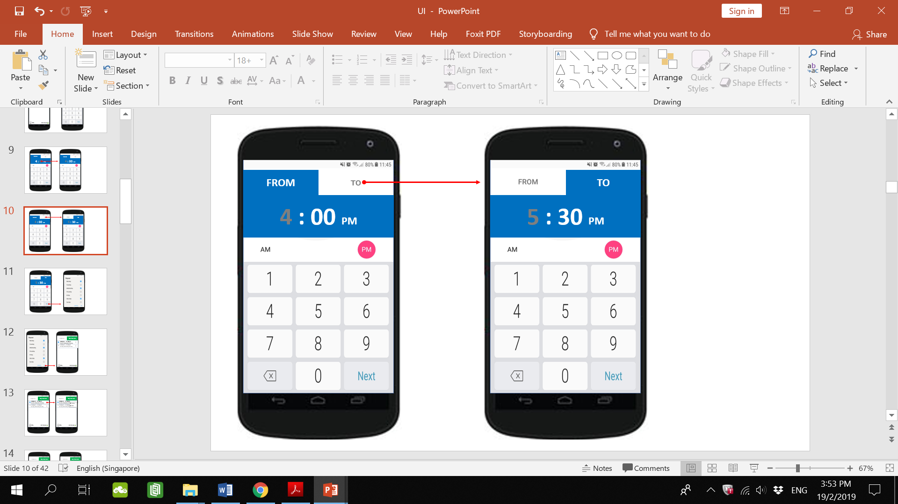

Select the To tab to enter the end time of the interval

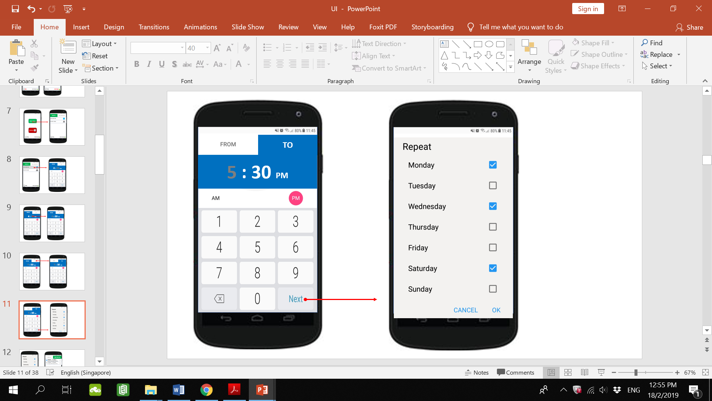

**Justification & Critique:**

When the user has entered the From and To times, select next to proceed. Upon selecting next (left), the user will be directed to the set days page (right). The user will select the days to repeat this interval via the checkboxes. When selected, the box will turn into a blue box with a tick on it, indicating that it has been checked. The checkboxes are spaced apart a good distance from one another so that it is easier to select one. At the bottom of the page, the OK button proceeds to the next page. The cancel button would bring the user back to the previous page.

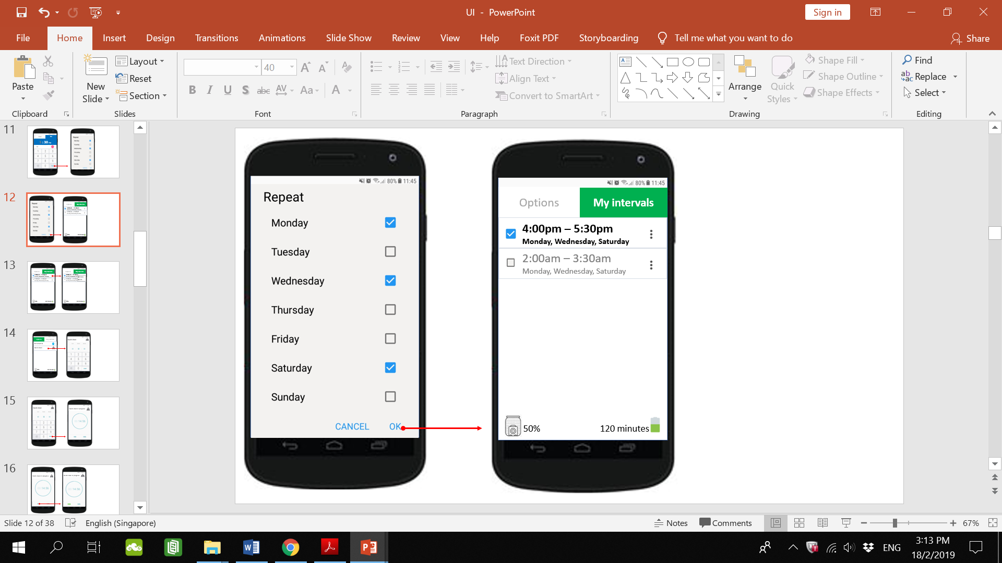

**Justification & Critique:**

Once the user has selected the days to repeat the interval and selected OK at the bottom (left). The user will be directed to the My intervals tab (right) where their intervals will be listed along with a checkbox to activate it and an options button beside it. Once activated, the checkbox of the interval will be blue with a tick and its details bolded while intervals not activated will be dimmed but still saved as even though the user does not want that interval to be activated, the user may still want to use the interval later in which case the user would just need to select its checkbox to activate it. No need to go through the process of setting the interval again This is in line with the Usability Heuristic of Recognition rather than recall. Due to the size of the row, the days of the interval are in very small font which may prove to be a challenge for Muhammad to see.

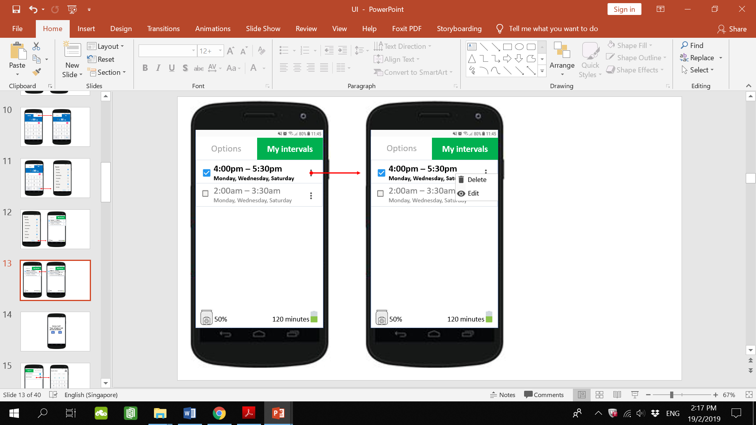

**Justification & Critique:**

Upon selecting the options button at the side of the interval a pop-up would show options to delete or edit the interval. The options button is very small and so is the pop-up with the delete and edit buttons. This would make it require more precision to select especially for someone with big fingers. The delete option deletes the interval while the edit option would direct the user back to the set interval timing page.

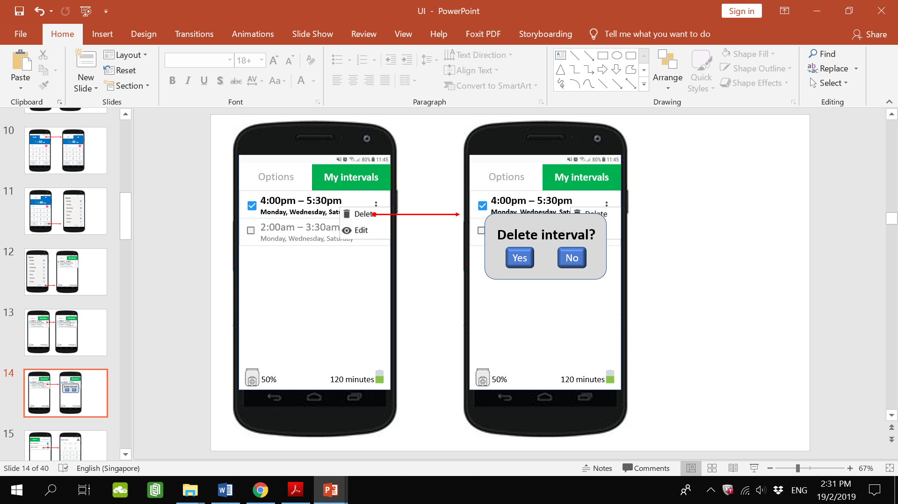

**Justification & Critique:**

If the user selects delete (left), the user will be prompted to confirm that deletion (right). This is in line with the Usability Heuristic of User control and freedom. In the case that the user mistakenly selected the delete option (left), the user is able to select No so that this mistake is easily rectified.

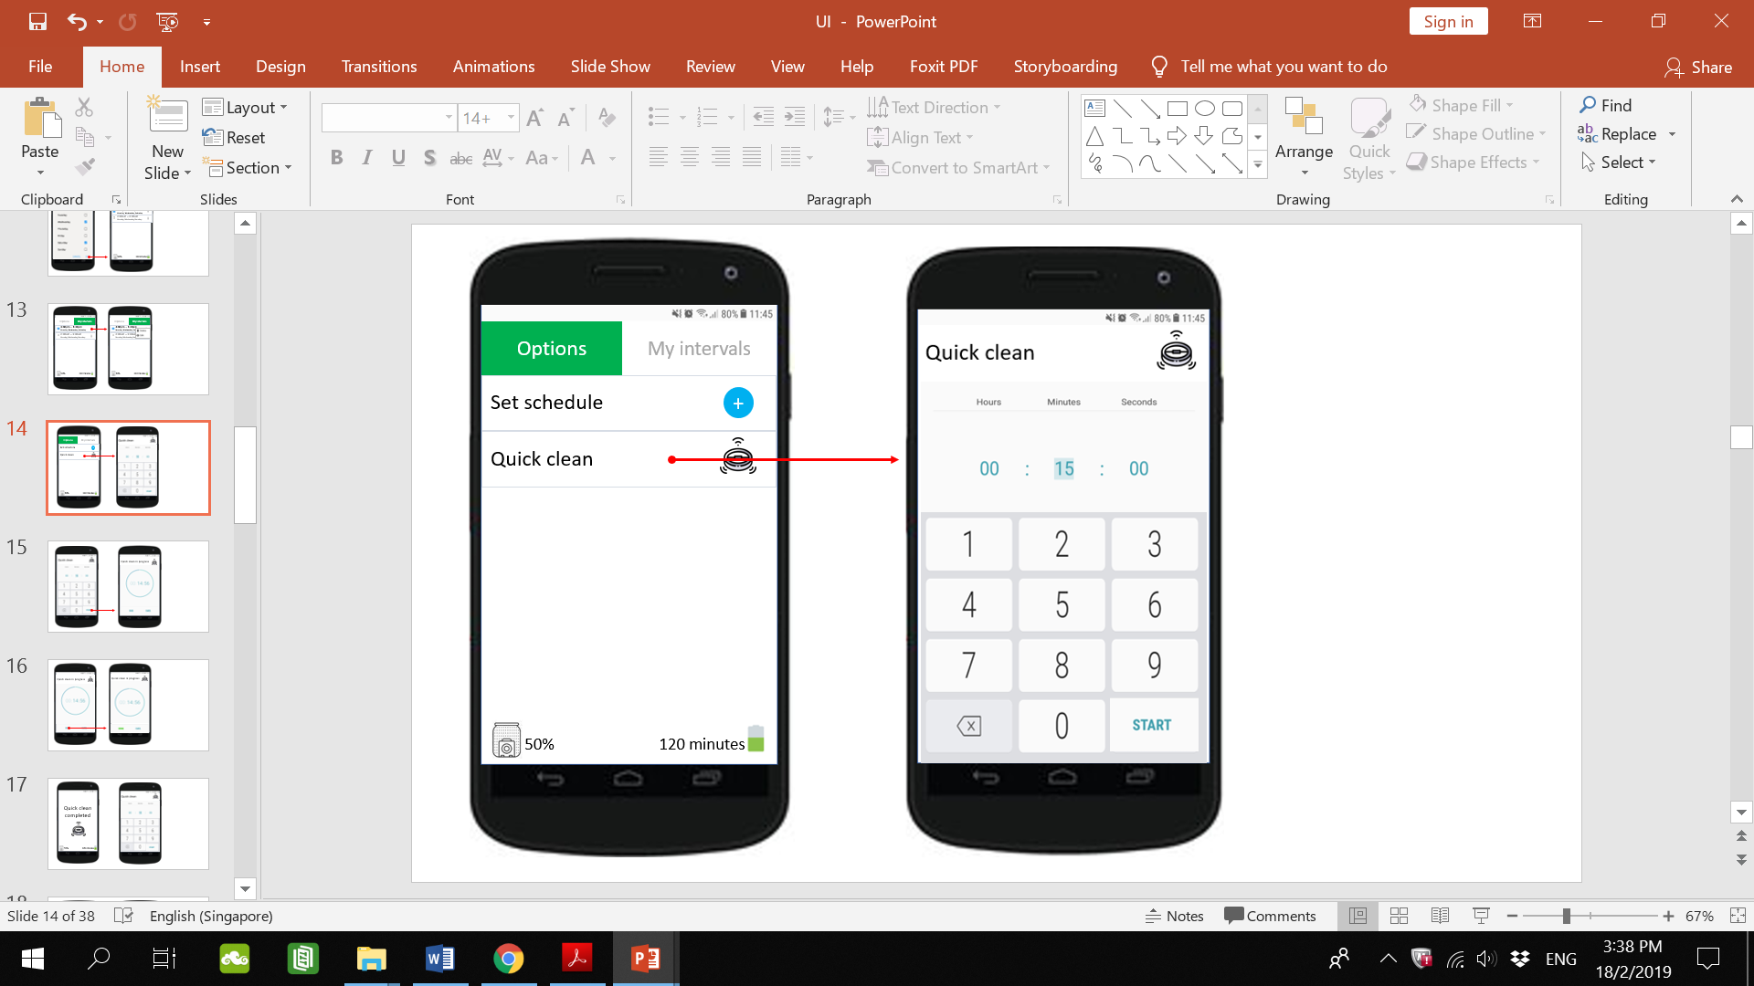

**Justification & Critique:**

Back to the Options tab. Upon selecting Quick clean option, the user will be directed to the set quick clean duration page. The user will have to enter the duration of the quick clean with a number keypad similar to the set interval timing page. In line with the Usability Heuristic of Preventing User Errors, constraints will be placed on the duration set by the user to align with the battery life of the UVac. In this case, the user will not be allowed to set a duration longer than 120 minutes. Similar constraints will be placed as is with the case in the set interval timing page; the range for seconds will be 0 to 59, the range for minutes will be 0 to 59. Once the duration has been entered, the user selects start at the bottom right to start the quick clean.

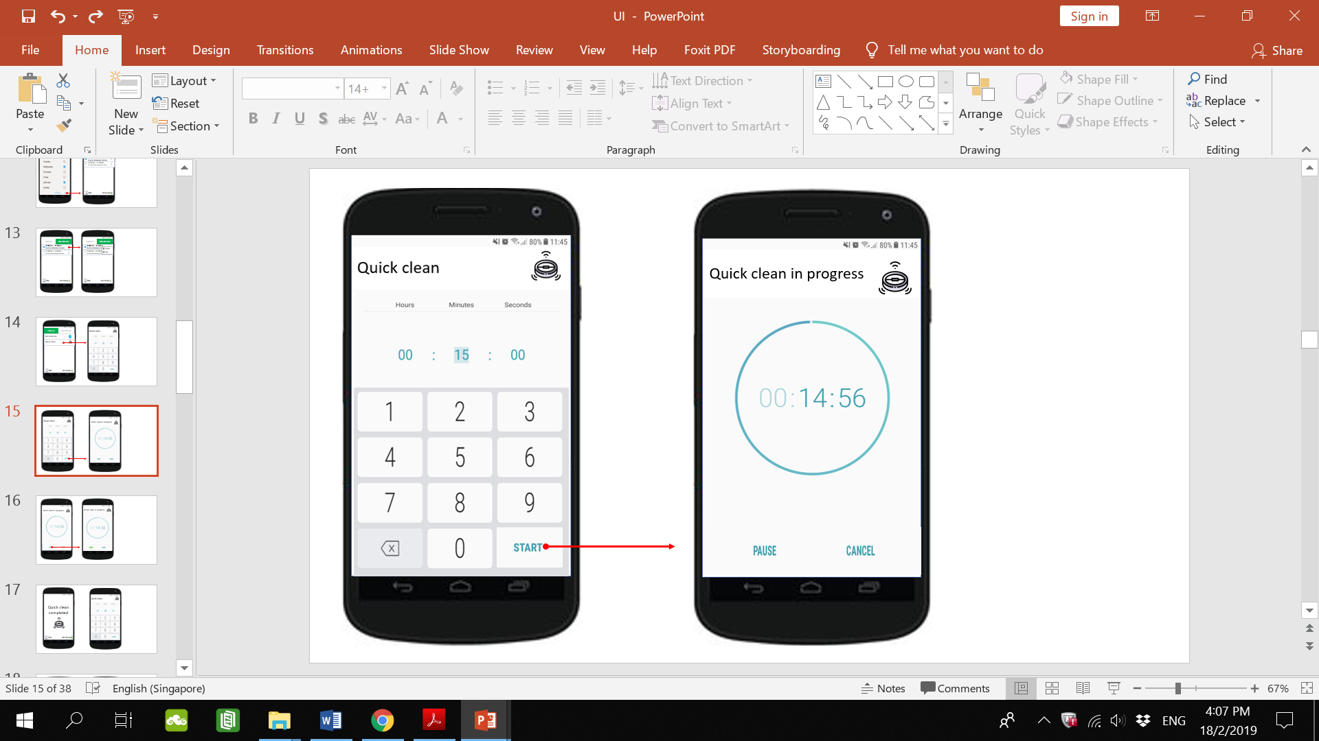

**Justification & Critique:**

Upon selecting start, the user will be directed to the Quick clean in progress page which will show a countdown timer which shows how much time is left in the quick clean. The time is shown in big font. This would be good for Muhammad who has poor eyesight. On the bottom, there is a pause button to pause the quick clean and a cancel button to cancel the quick clean and return the UVac to its charging dock.

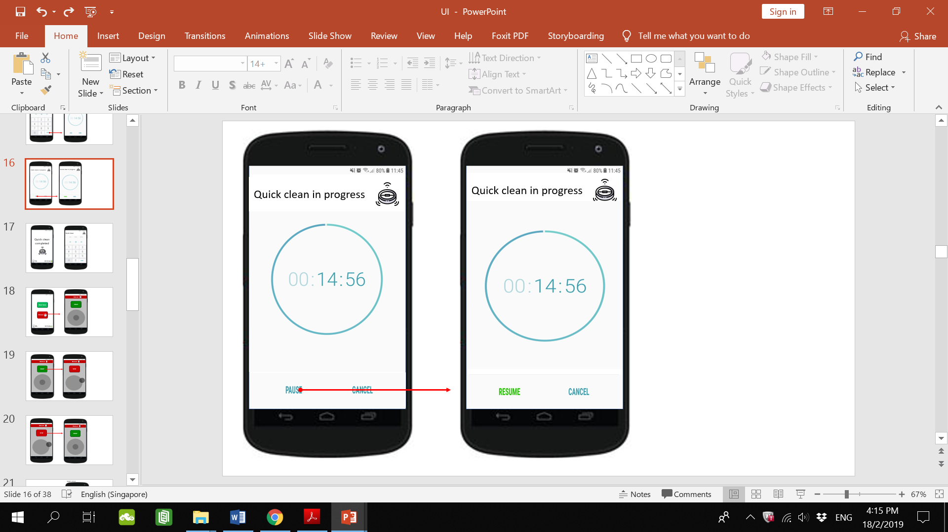

Once paused, the quick clean can be resumed or cancelled.

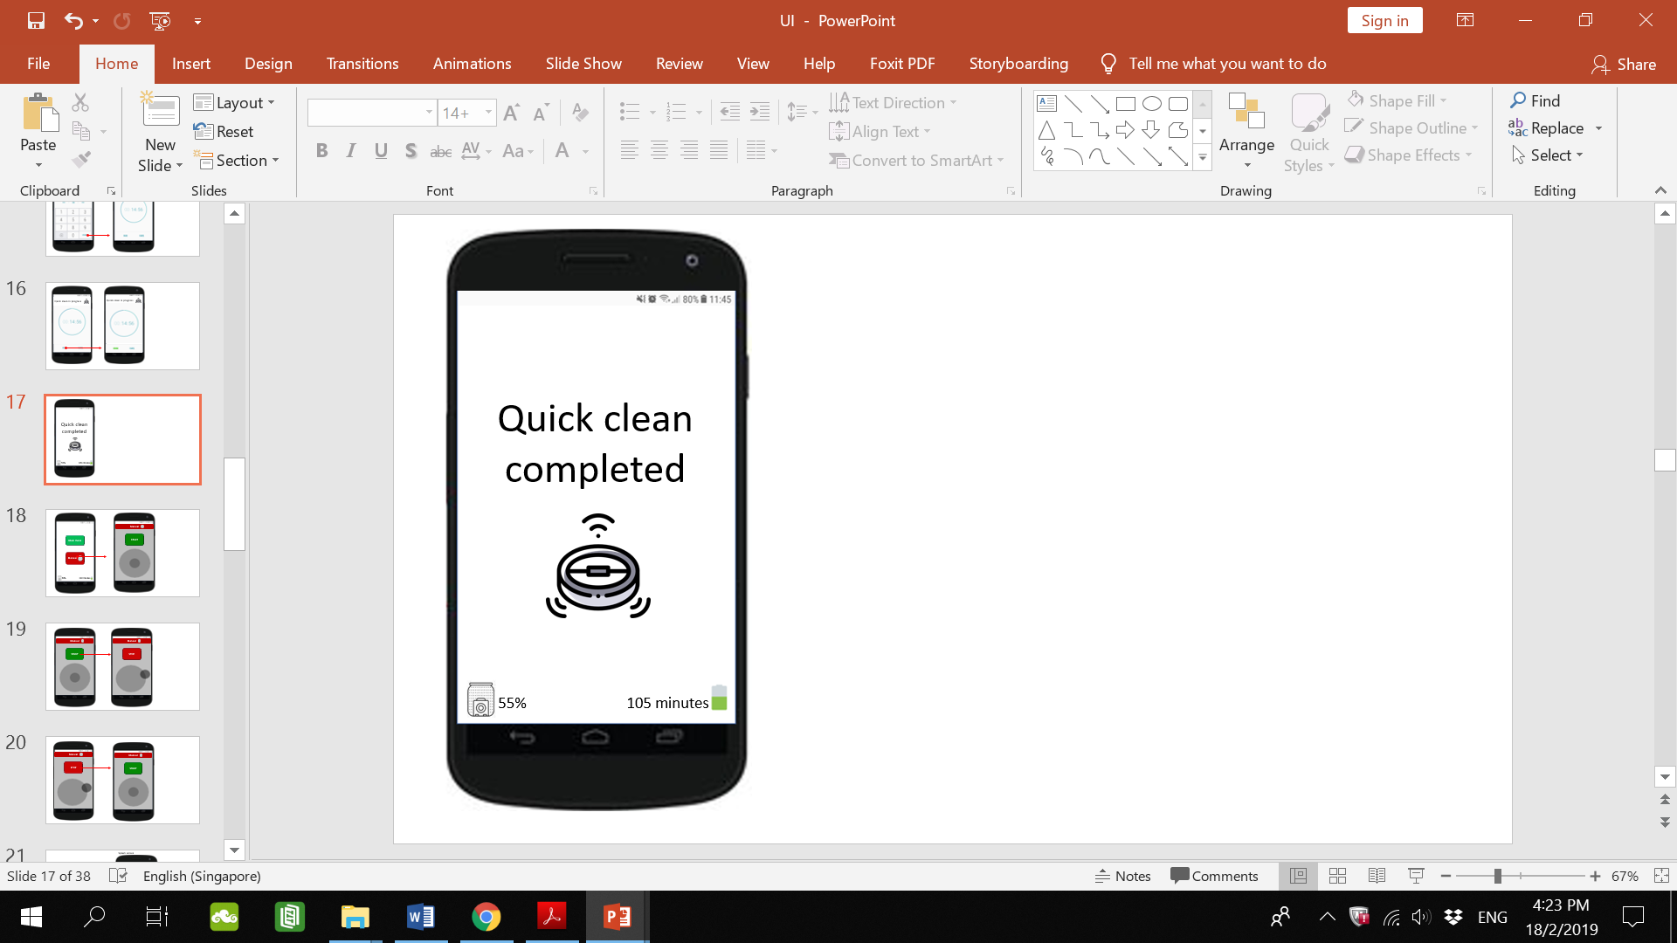

**Justification & Critique:**

Once completed, the mobile phone will vibrate and the above message will appear to show that the quick clean has been completed. It consists of the words quick clean completed in large font and the quick clean logo. This page will also show the dust bag capacity and battery life left. This is in line with the Usability Heuristic of Visibility of System Status.

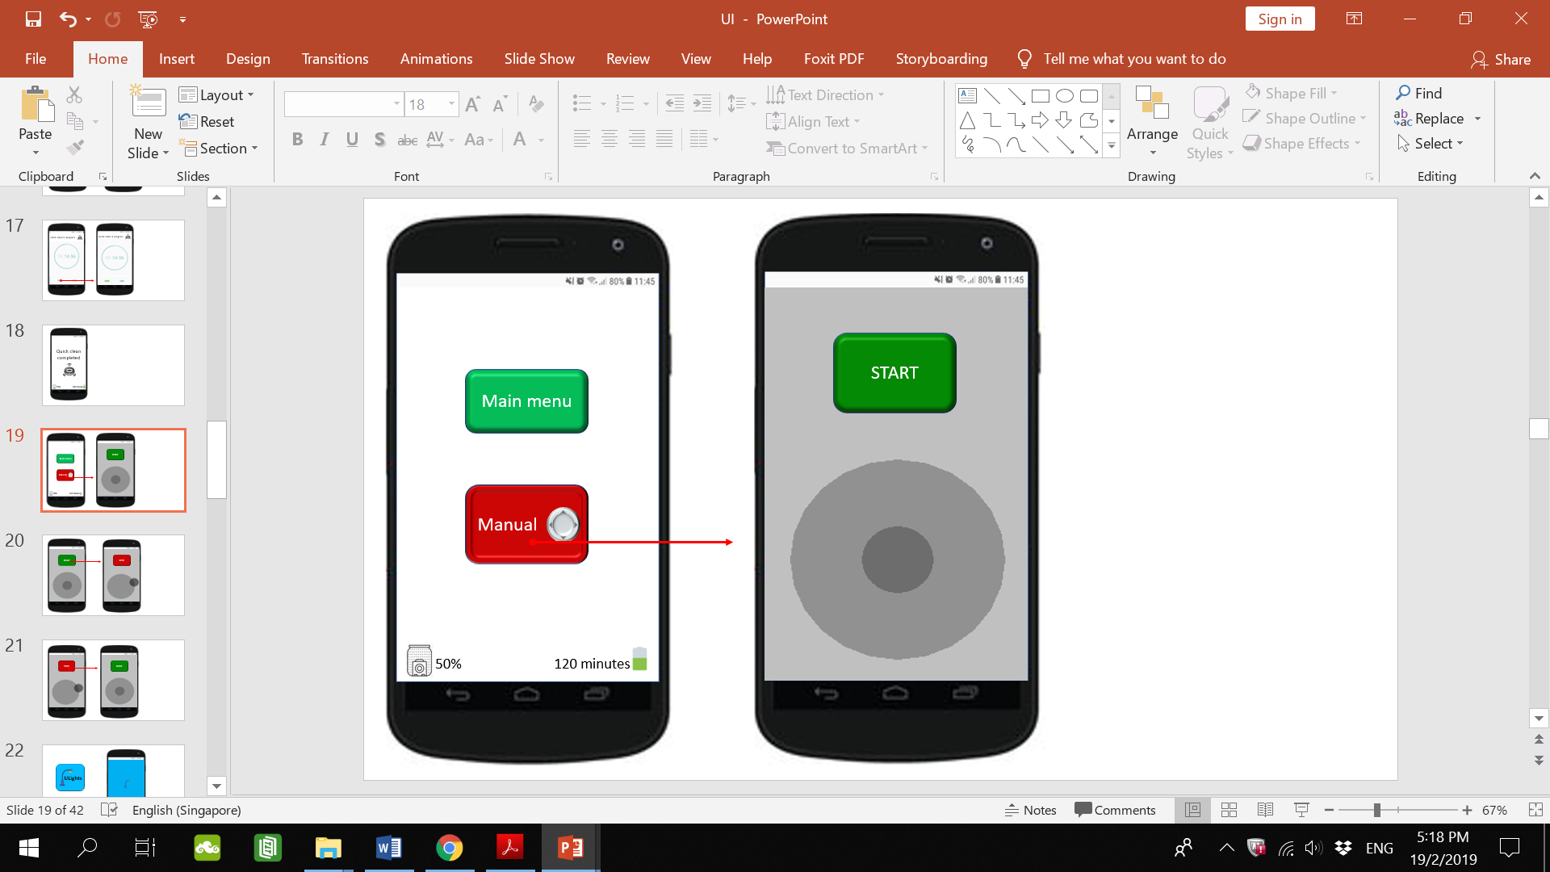

**Justification & Critique:**

Back to the homepage, upon selecting the manual option (left), the user will be directed to the manual control page (right). It consists of a start button and a virtual joystick. The simple, minimalist design is in line with the Usability Heuristic of Aesthetic and minimalist design. The buttons (i.e. Main menu, Manual, Start) may look cartoonish to some people. The elderly such as Muhammad may not know how to use a virtual joystick.

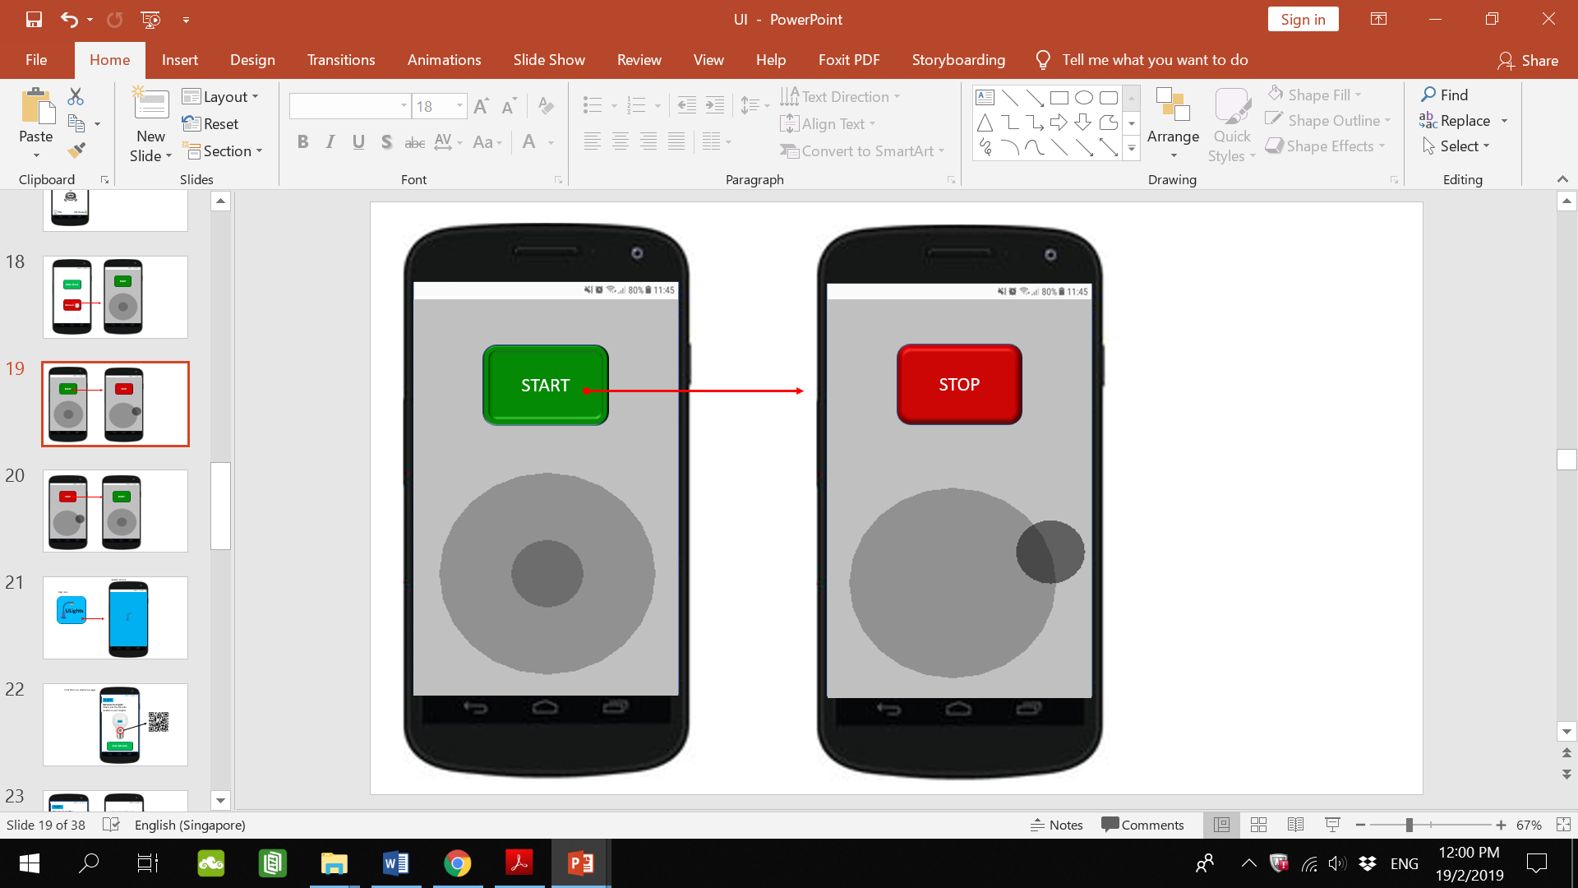

Once the user selects the start button (left), the UVac will start sucking and a stop button takes its place (right). The user manoeuvres their UVac by moving the virtual joystick around.

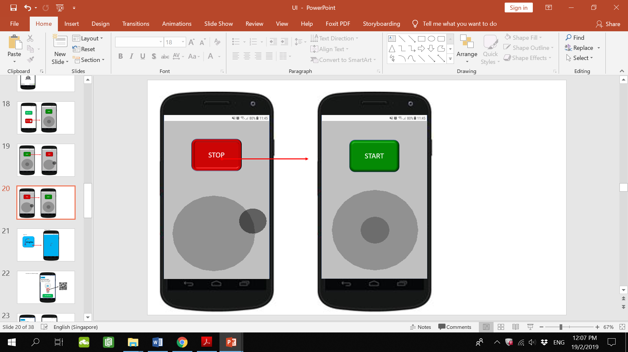

Selecting stop (left) would stop the UVac sucking and the start button takes its place (right).

**ULights**

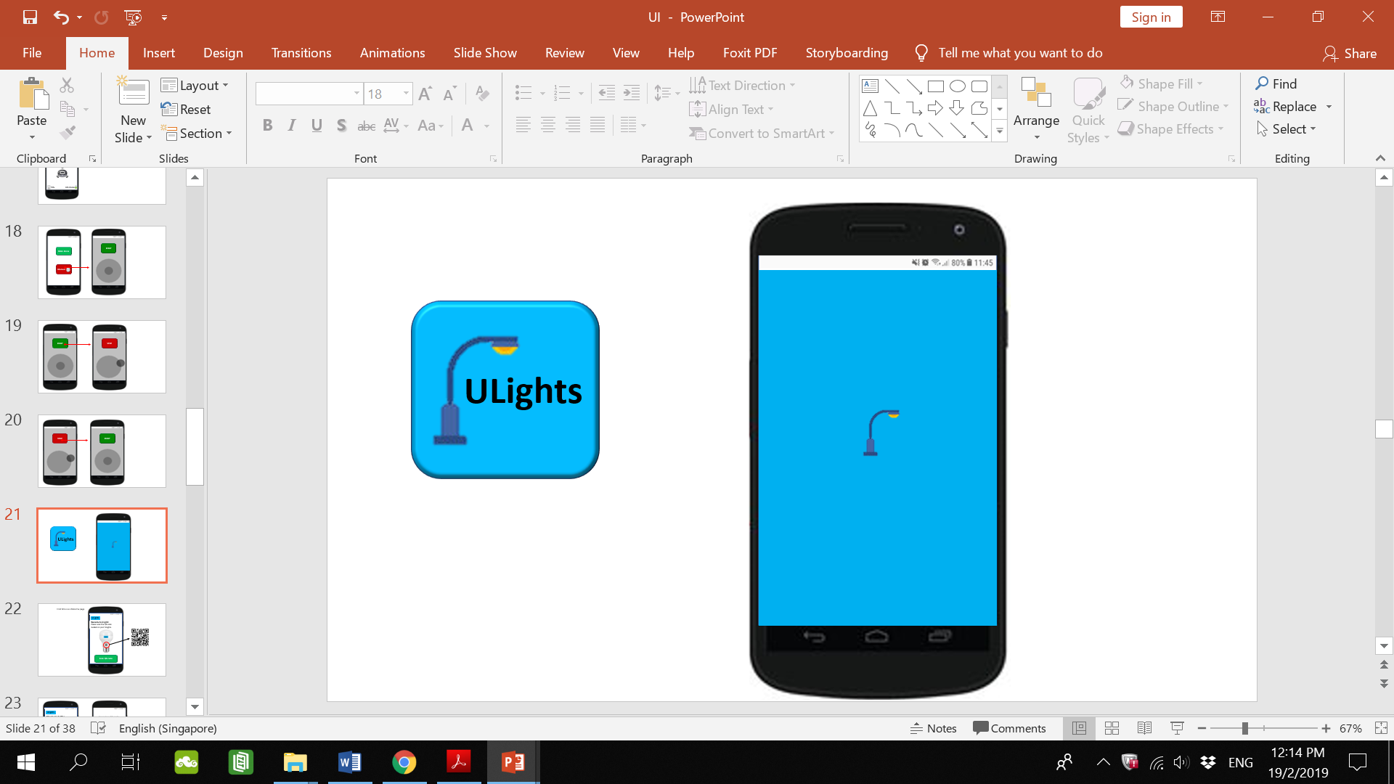

**Justification & Critique:**

ULights’s app icon has the app name in relatively large font. This would make it easy for Muhammad to identify it instantly.

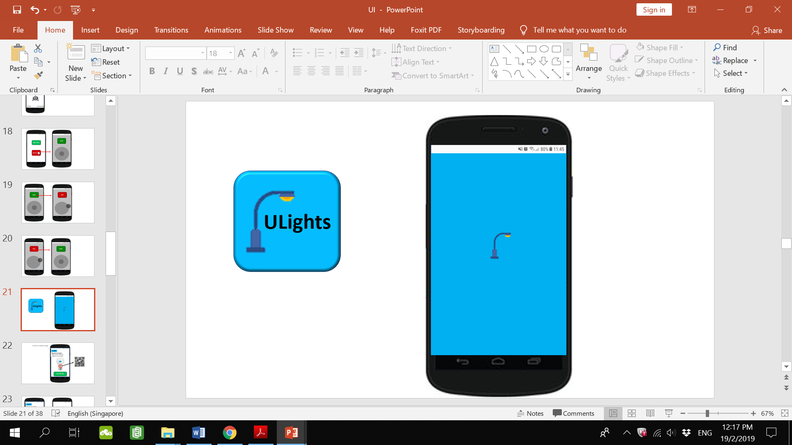

**Justification & Critique:**

Upon selecting the app, the app launches and this splash screen appears. Also called a load screen, it does not have any functional elements. Splash screen is a good way of letting users know that the app is in the process of starting and has not crashed upon launch. This is in line with the Usability Heuristic of Visibility of System Status. The user is kept informed of what is going on.

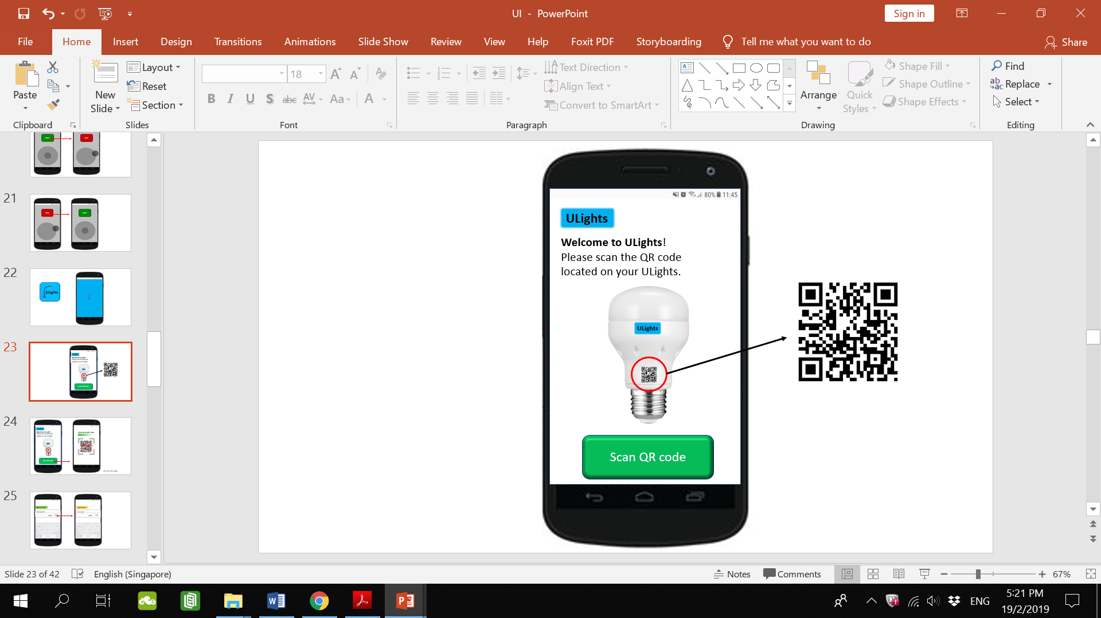

**Justification & Critique:**

For the first time use the user will be prompted to scan the QR code on their ULights to link it to the app. An image shows where the QR code is located and there is a button to start the scan. This makes it clear to the user on what to do. The user does not have to search too long for the QR code on their ULights.

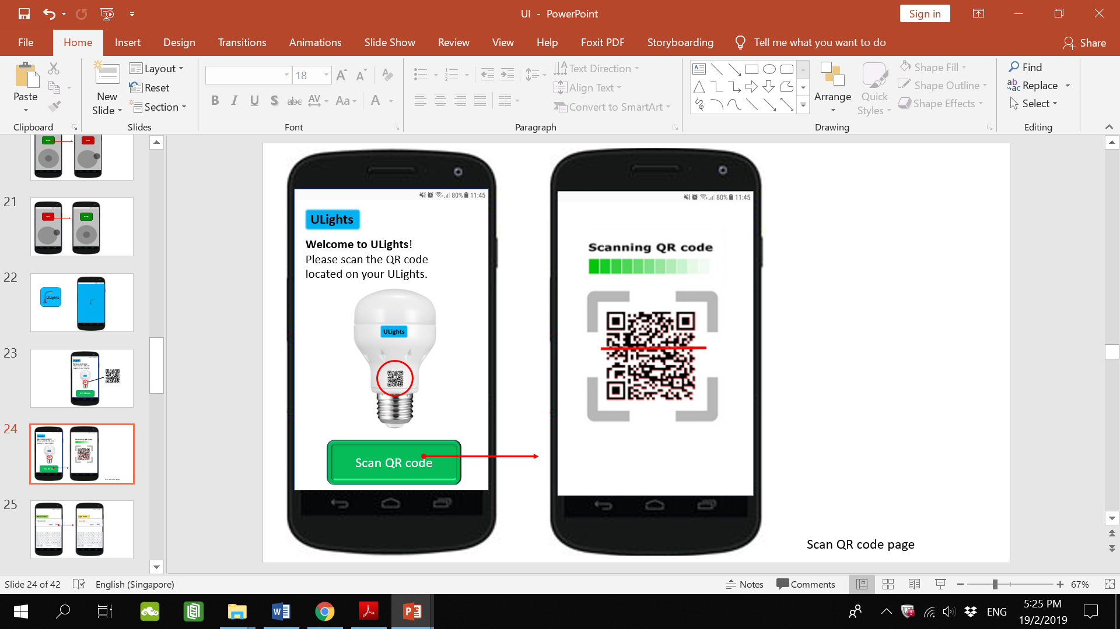

**Justification & Critique:**

The “Scan QR code” button makes an indentation when selected showing that it has been selected (left). There is a loading bar when scanning the QR code (right). These are in line with the Usability Heuristic of Visibility of System Status.

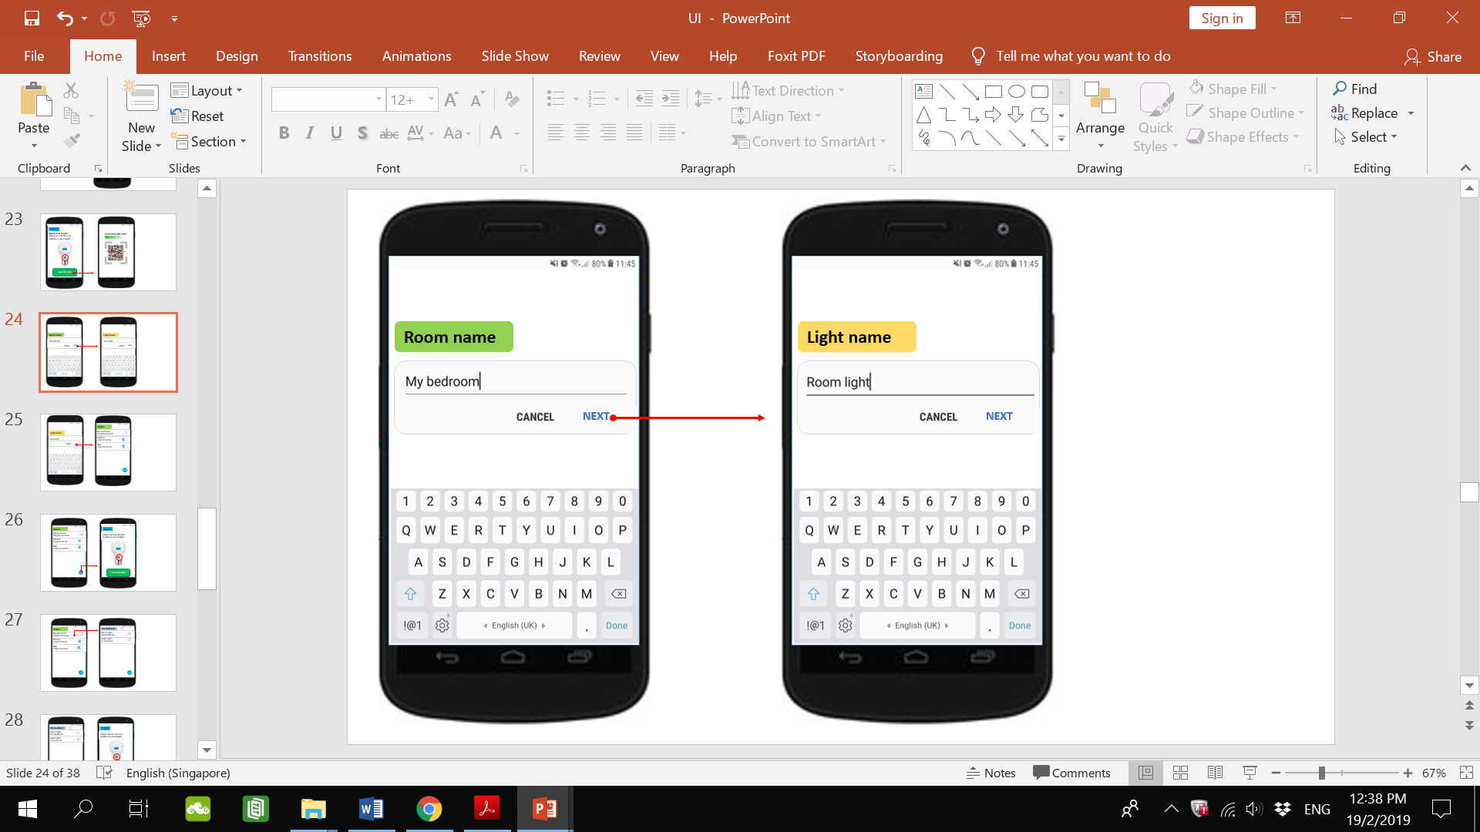

**Justification & Critique**

After the QR code has been scanned, the user will be prompted to enter the name of the room the light will be in (left) and name the light (right). These pages consist of a header, a textbox, buttons to cancel or go to the next page and a keypad. Depending on the phone screen size, the keypad may cause problems for those with big fingers as it may result in selecting the wrong alphabet. A way to solve this is to provide a list of names that the user can select such as “Bedroom, Kitchen” and “Table lamp, Bedside lamp”. This would minimize the typing that the user has to do.

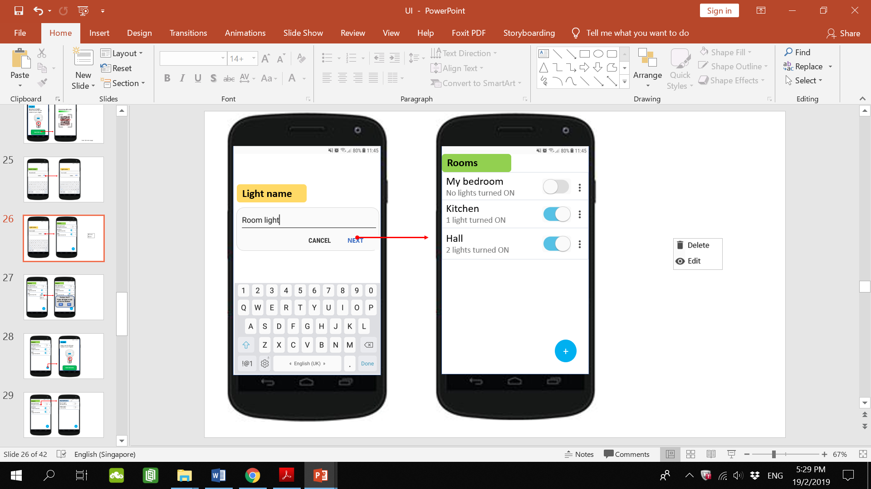

**Justification & Critique**

After naming the light and selecting next (left), the user will be directed to a page with the list of rooms that they have (right). In the example shown above, there are 3 rooms namely, My bedroom, Kitchen and Hall. Below the room name in small font is the number of lights turned ON in that room. This keeps the user informed. Muhammad may find the font too small to see because of his poor eyesight. To the right of each room name is a toggle to turn all lights in the room on or off. If the white circle is to the left, it means that all lights in that room are turned off. Selecting it would move the white circle to the right and switch all lights in that room ON. If one is not familiar with toggle buttons, they may not know its function. One way to solve this is to explicitly state on the toggle the words “ON” or “OFF”. To the right of each toggle is an options button. Selecting this button would give options to delete the room or edit its name. Note that deleting the room would delete all lights that are in it.

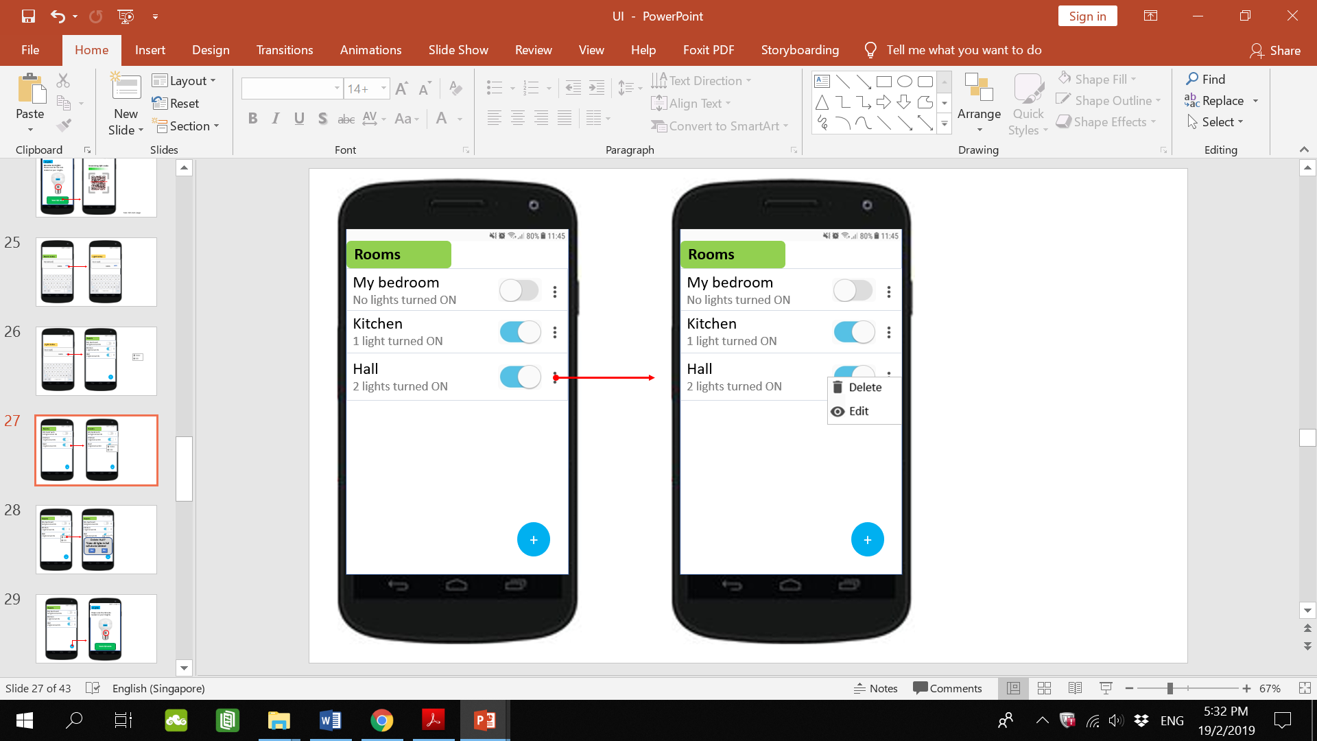

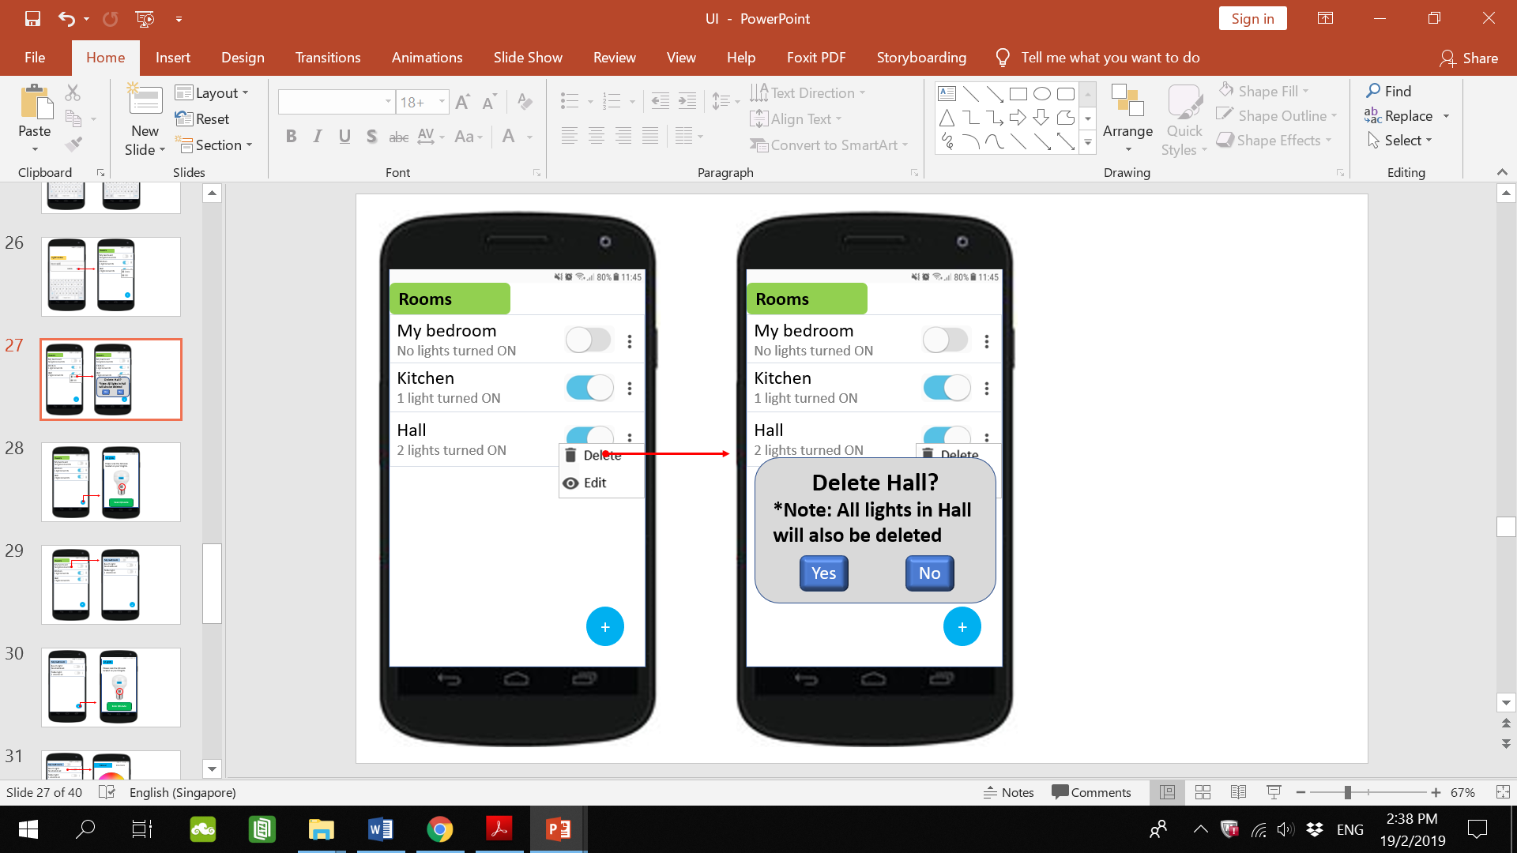

**Justification & Critique:**

If the user selects delete (left), the user will be prompted to confirm that deletion (right). This is in line with the Usability Heuristic of User control and freedom. In the case that the user mistakenly selected the delete option (left), the user is able to select No so that this mistake is easily rectified.

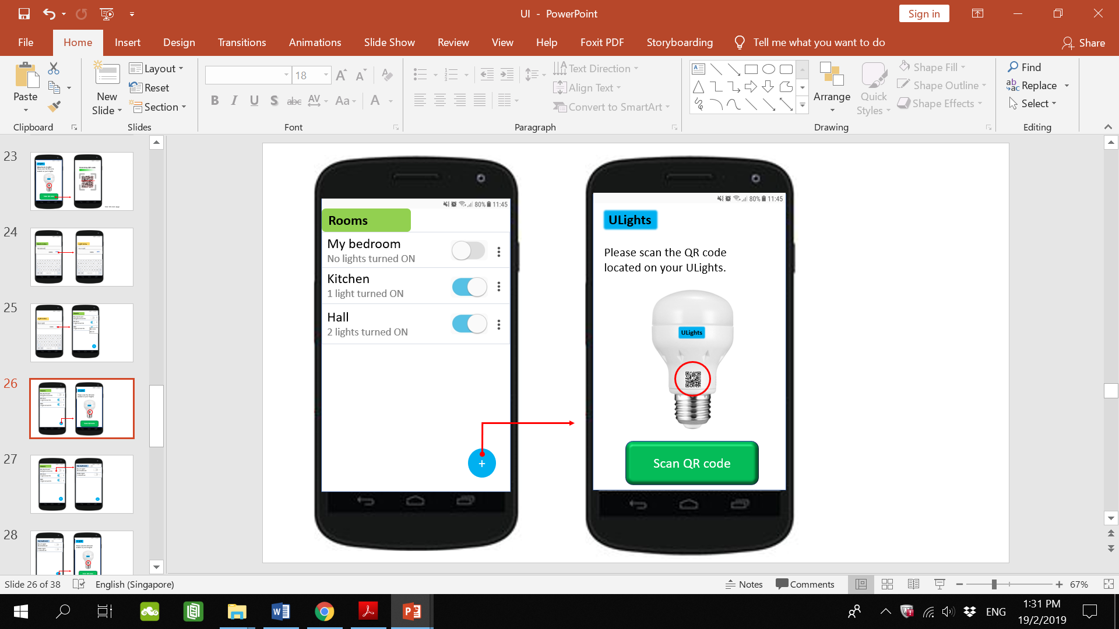

**Justification & Critique**

To the bottom of the page there is an add room button (left). The user would select this button to add a room. Selecting this button would direct the user to scan the QR code of a ULights as a room cannot exist on the app without a ULights in it. This is a form of error prevention so that there would not be a room on the list of rooms without a ULights in it as it would be redundant. This is in line with the Usability Heuristic of Error prevention.

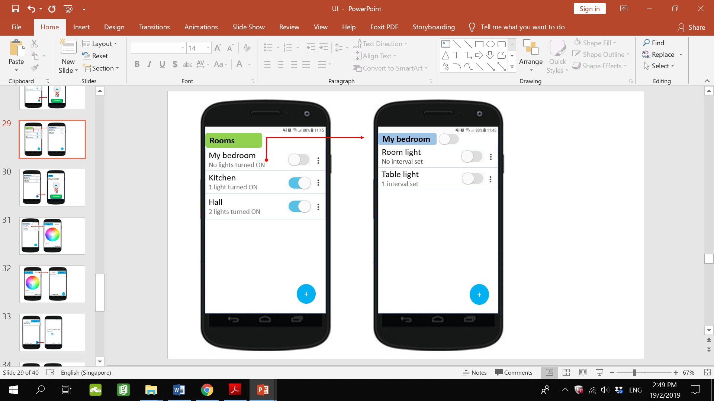

Selecting a room (left) would direct the user to a page with the list of lights in that room (right). In the example above, when My bedroom is selected, the next screen shows that there are 2 lights in that room, namely, Room light and Table light. To the right of the list are a toggle button and an options button and the bottom right of the screen there is an add light button. These features are similar to the ones mention previously. Below the name of the light, in small font shows how many intervals are set for that light. This keeps the user informed.

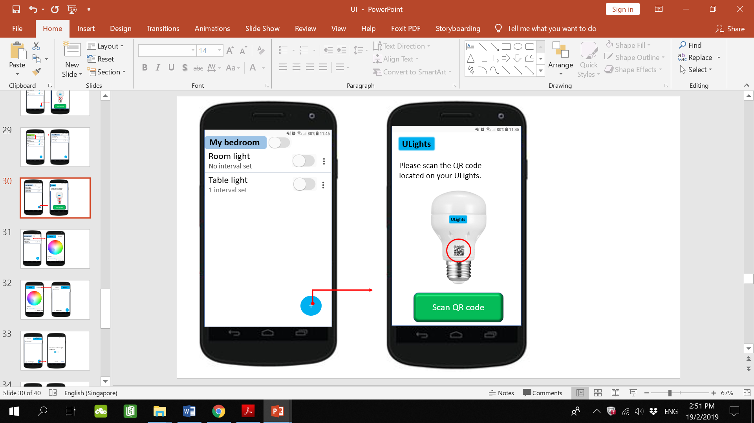

**Justification & Critique**

To the bottom of the page there is an add light button (left). The user would select this button to add a light to this room. Selecting this button would direct the user to scan the QR code of a ULights to add it to the room.

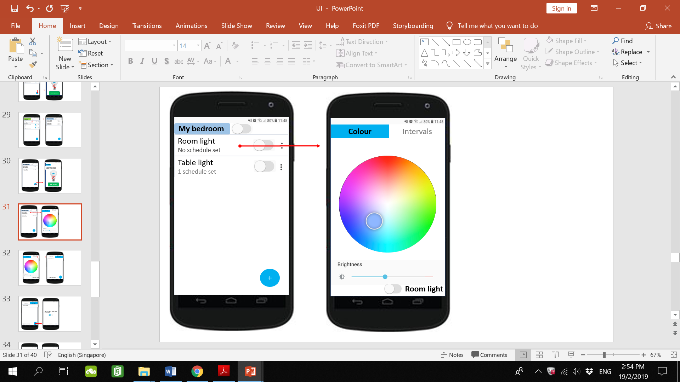

**Justification & Critique**

Selecting the name of the light in the list (left) would direct the user to a page with 2 tabs, (right) Colour and Intervals. The default selected is the Colour tab where the user can change the colour of the light by selecting a colour in the circle of colours. The colour of the light will change instantaneously (if the light is ON which in this case it is not). Below the circle of colours is a sliding bar to adjust the brightness of the light and at the bottom right of the page is a toggle button to turn the light ON/OFF and the name of the light. This is to remind the user of which light they are adjusting. This is in line with the Usability Heuristic of Recognition rather than recall.

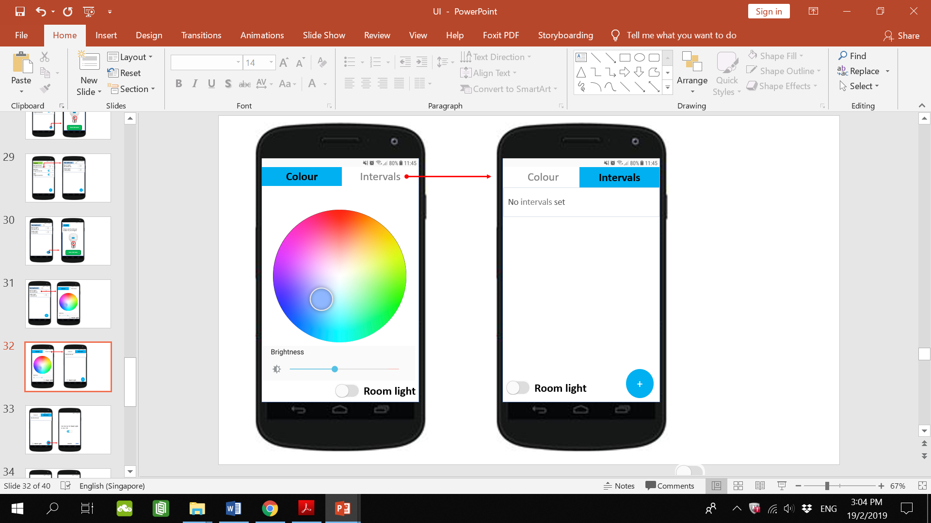

**Justification & Critique**

Selecting the intervals tab (left), will present the user with a list of intervals set for that light (right). In this case, no intervals have been set. The user would select the add interval button at the bottom right of the page to add an interval.

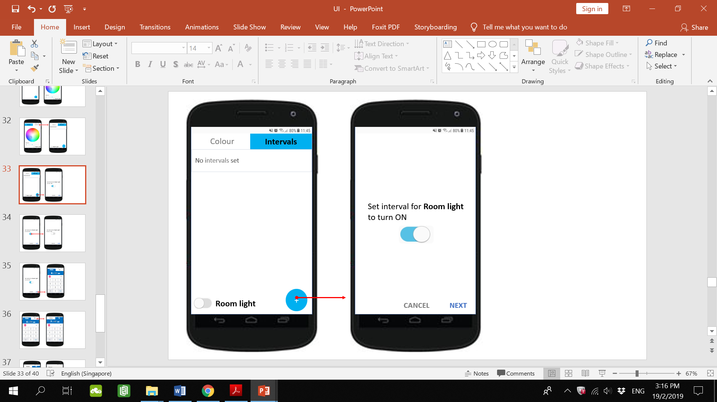

Upon selecting the add interval button, (left) the user would be prompted to select whether to set the light to turn ON or OFF during the interval (right).

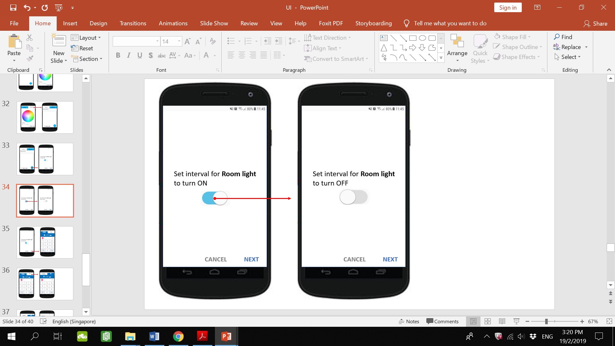

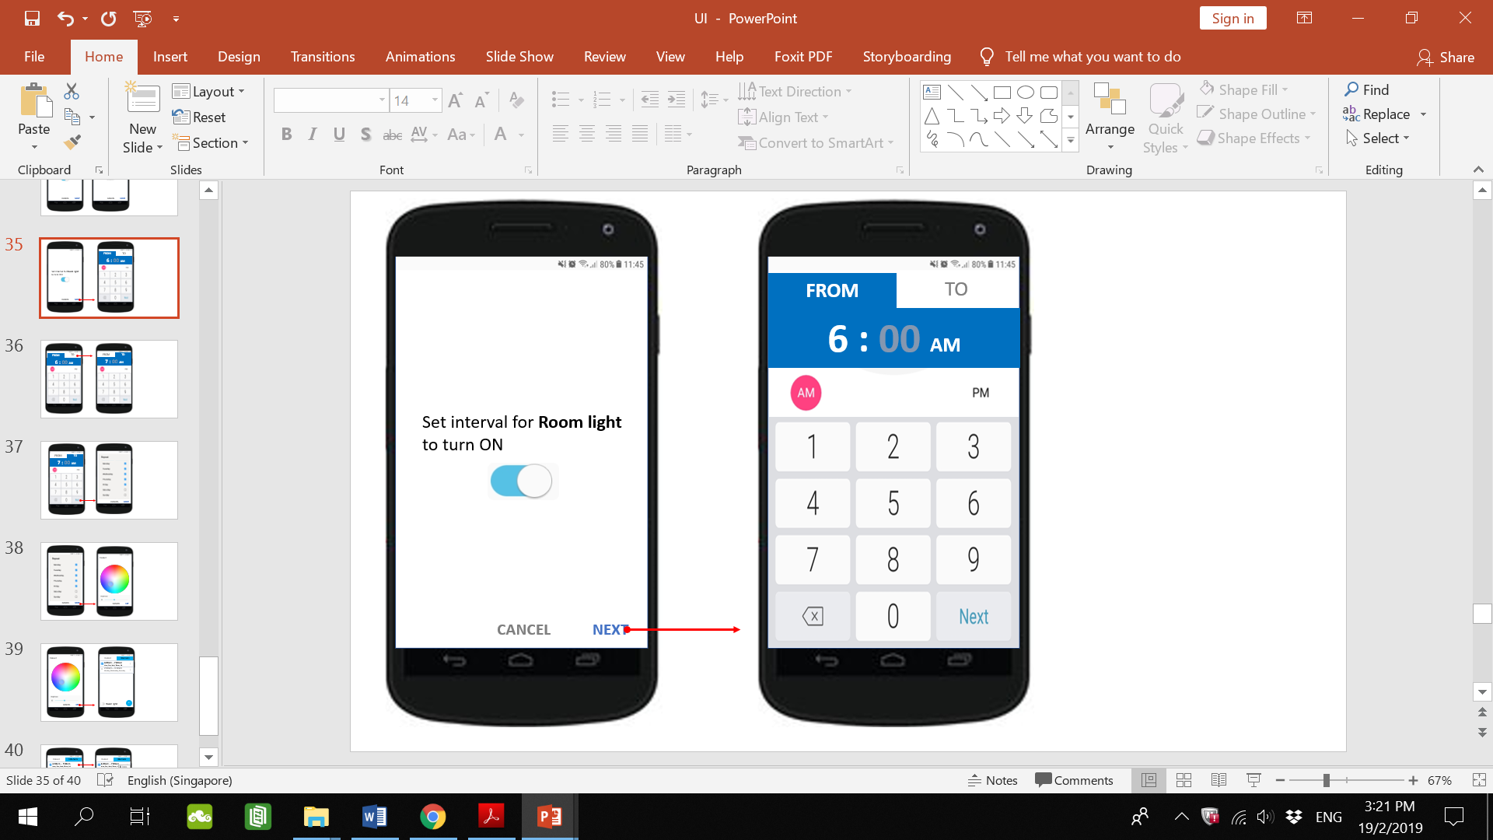

**Justification & Critique:**

Upon selecting ON or OFF for the interval and selecting next (left), the user will be directed to the set interval timing page (right). It consists of two tabs; From and To. The tab buttons are relatively big so that they can be easily selected. In the From tab, the user enters the time to start the interval. In the To tab, the user enters the time to end the interval. The keypad for entering numbers have big buttons for the numbers so that they can be easily selected. It also contains a backspace button on the bottom left for the user to delete in case the wrong number is entered. This is in line with the Usability heuristic of User control and freedom due to having an undo function. In line with the Usability Heuristic of Match between system and the real world, 12-hour clock format is used as seen by the AM or PM selector. This is because this format is more widely used and understood. The selected option (PM) will be highlighted with a pink circle to show that it is the selected option.

In this instance, the hour number (6) is in white indicating that the user is currently entering the hour portion of the time.

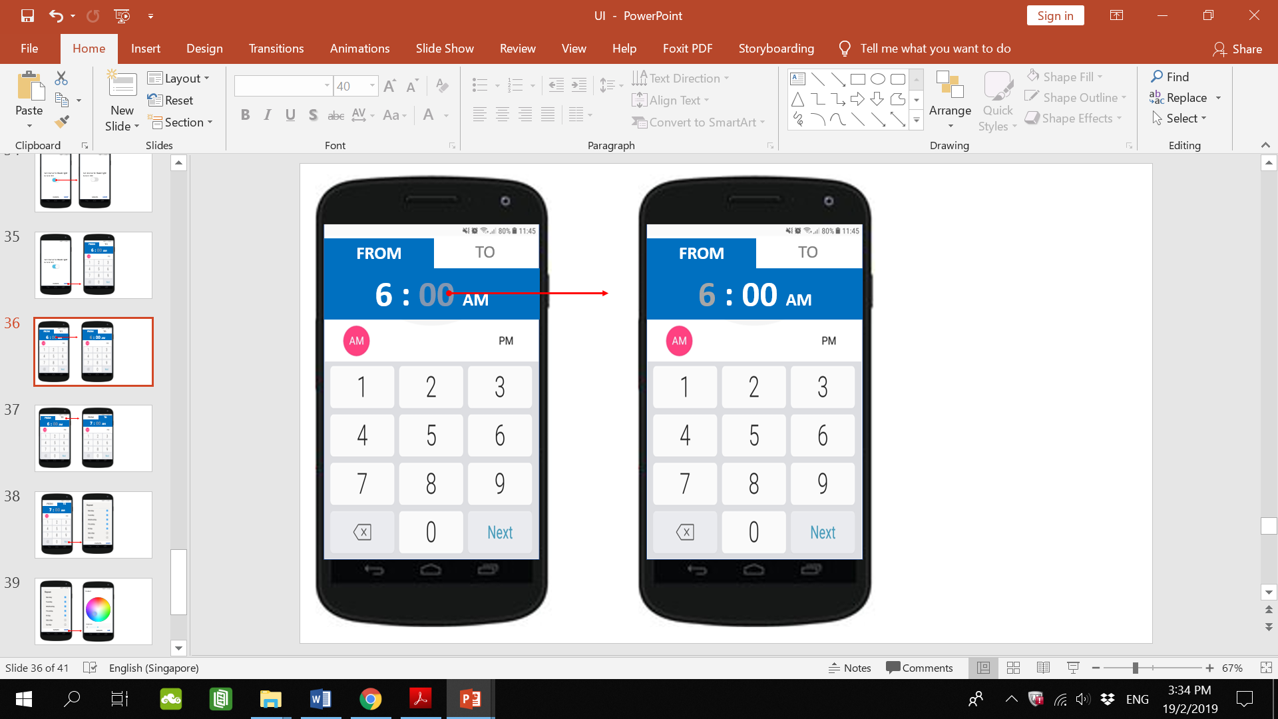

**Justification & Critique:**

When the user selects the minutes part of the time (left), those numbers will turn white (right) indicating that the user is currently entering the minutes of the time. Note that it is not necessary for the user to select the minutes part as after the hour part has been entered, the system will go on to the minutes part (minutes numbers will turn white). This is just to illustrate that both hours and minutes part can be selected in case adjustments need to be made.

In line with the Usability Heuristic of Preventing User Errors, constraints will be used on how the user sets the time. For example, 39:78 PM makes no sense hence there is a potential for error here. Therefore, the hours will have a range constraint from 1 to 12 and minutes will have a range constraint from 0 to 59.

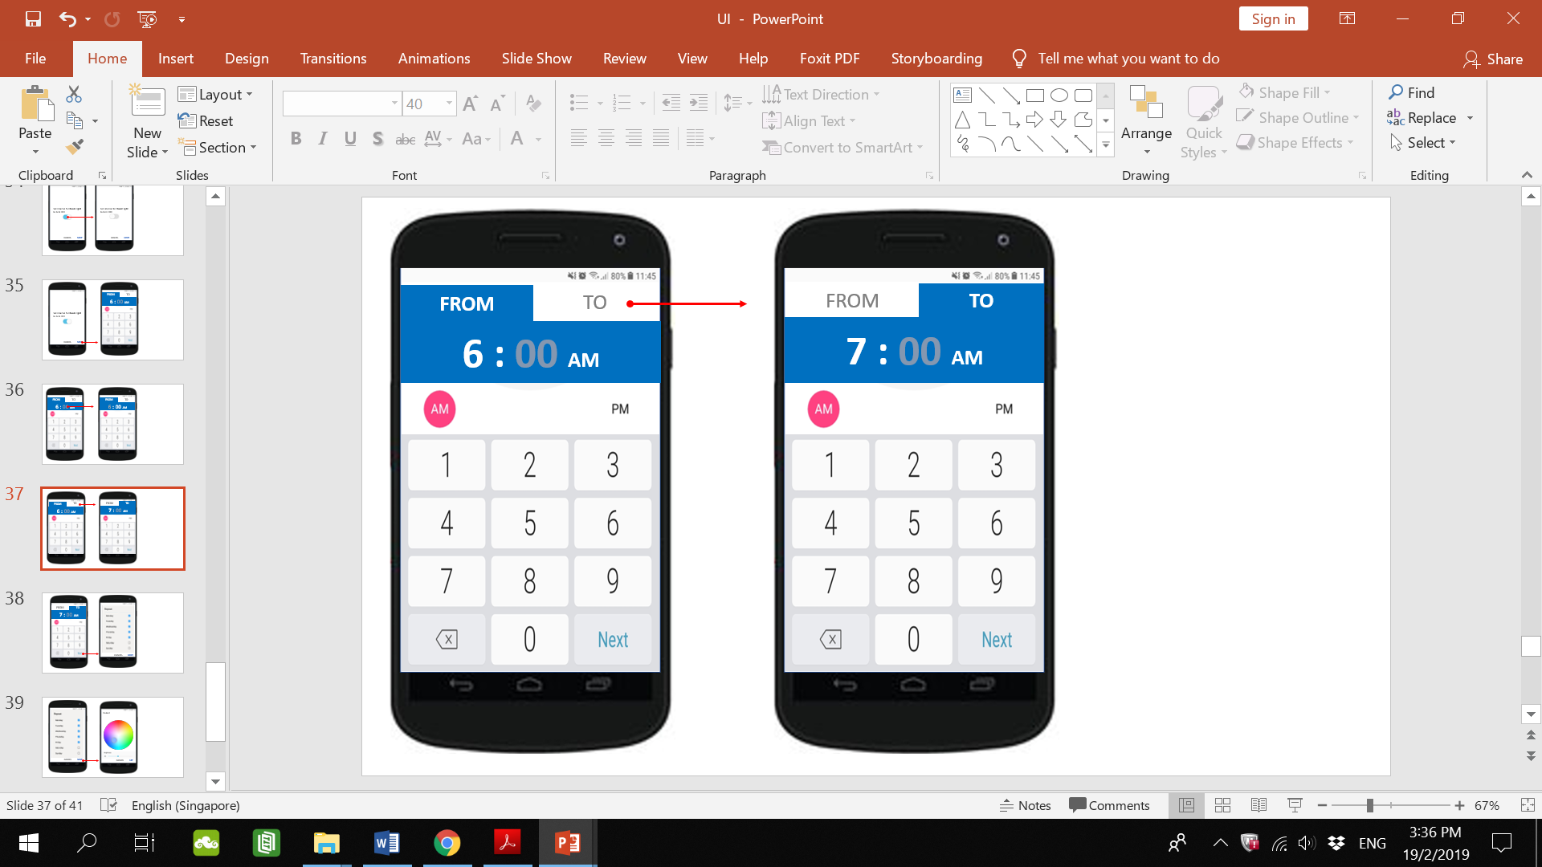

Select the To tab to enter the end time of the interval.

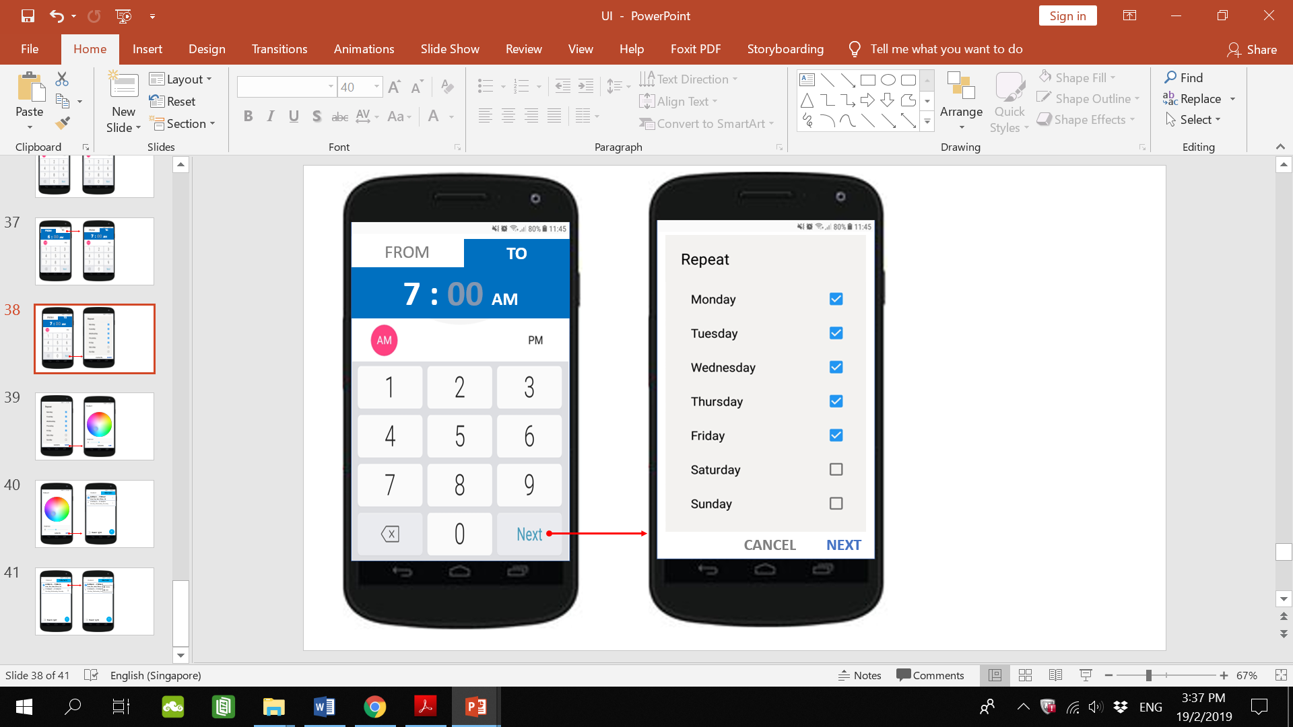

**Justification & Critique:**

When the user has entered the From and To times, select next to proceed. Upon selecting next (left), the user will be directed to the set days page (right). The user will select the days to repeat this interval via the checkboxes. When selected, the box will turn into a blue box with a tick on it, indicating that it has been checked. The checkboxes are spaced apart a good distance from one another so that it is easier to select one. At the bottom of the page, the next button proceeds to the next page. The cancel button would bring the user back to the previous page.

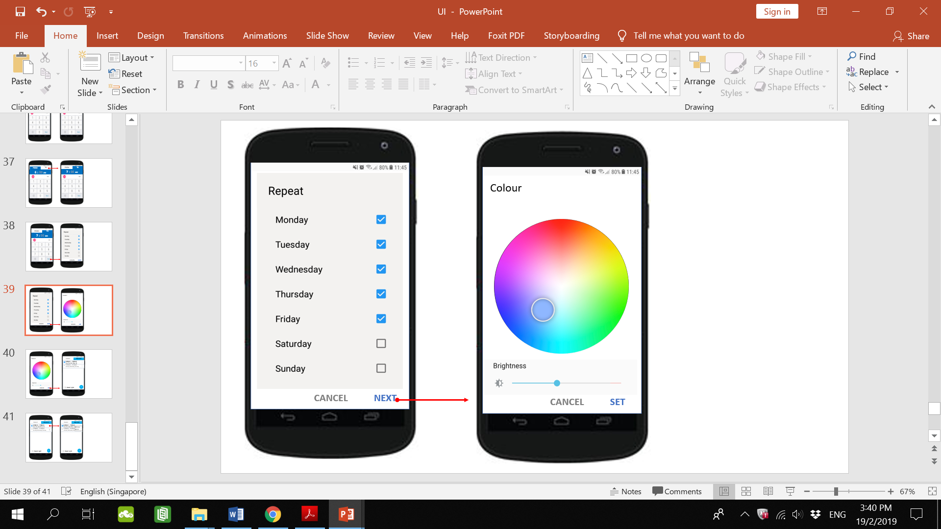

Upon selecting next (left), the user will be directed to the set colour page (right) where the user will select the colour and brightness of the light during the interval. When done the user will select set button at the bottom right.

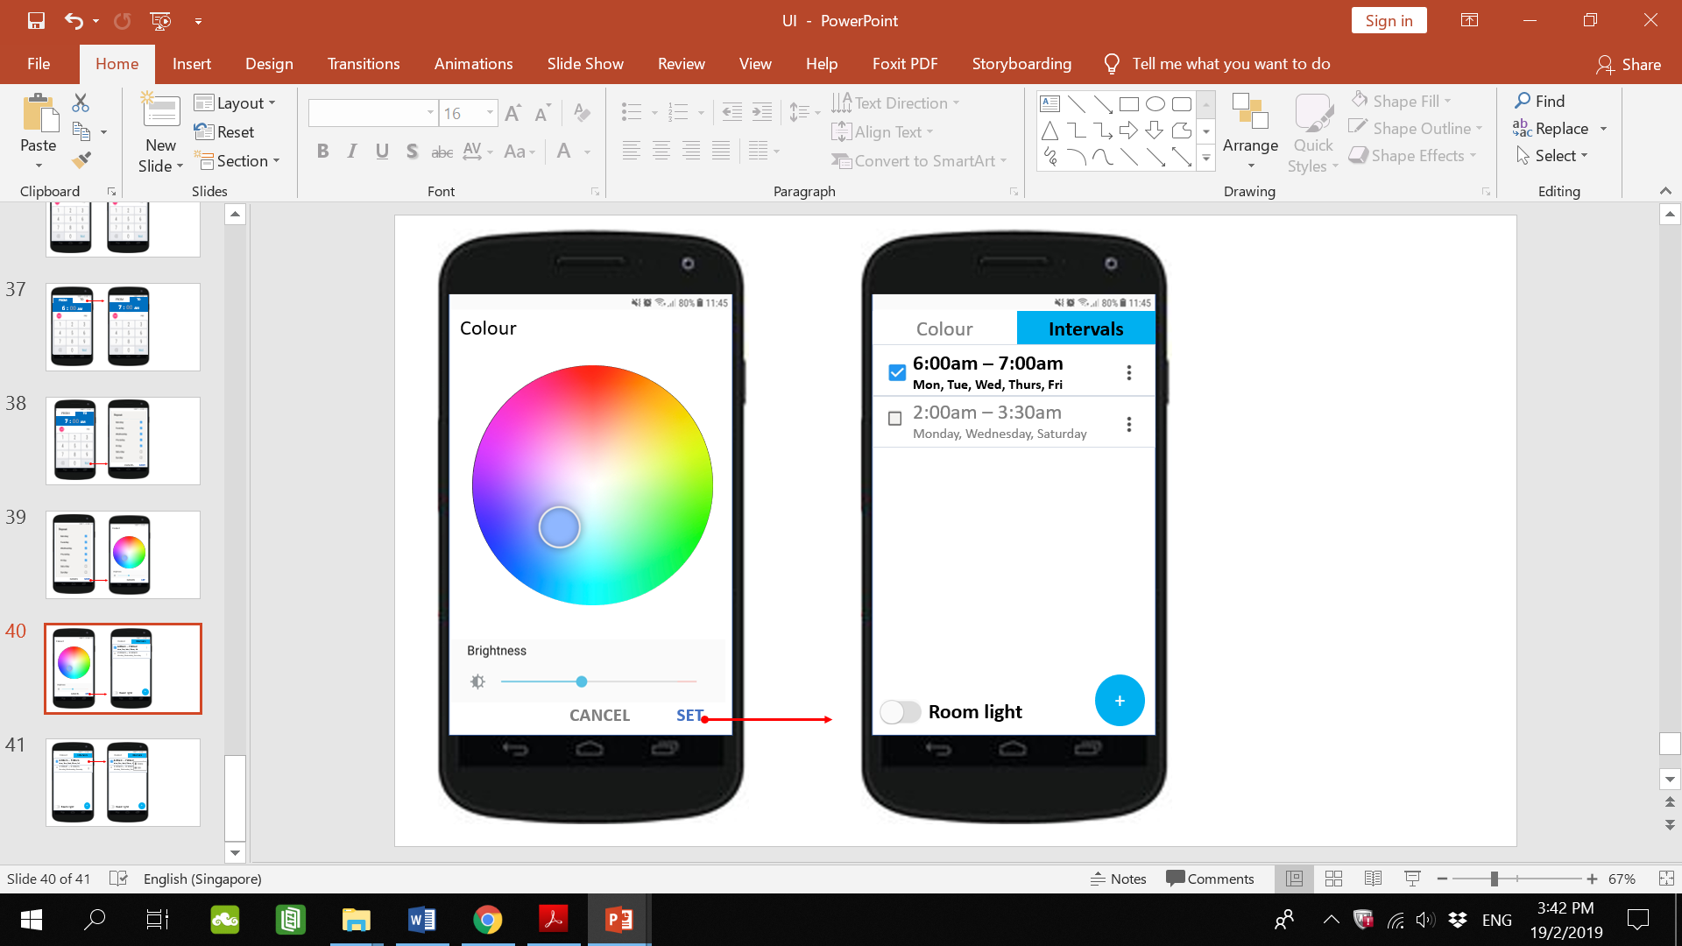

**Justification & Critique**

Upon selecting set, the user will be directed to the Intervals tab (right) where their intervals will be listed along with a checkbox to activate it and an options button beside it. Once activated, the checkbox of the interval will turn into blue with a tick and its details bolded while intervals not activated will be dimmed but still saved as even though the user does not want that interval to be activated, the user may still want to use the interval later in which case the user would just need to select its checkbox to activate it. No need to go through the process of setting the interval again This is in line with the Usability Heuristic of Recognition rather than recall. Due to the size of the row, the days of the interval are in very small font which may prove to be a challenge for Muhammad to see.

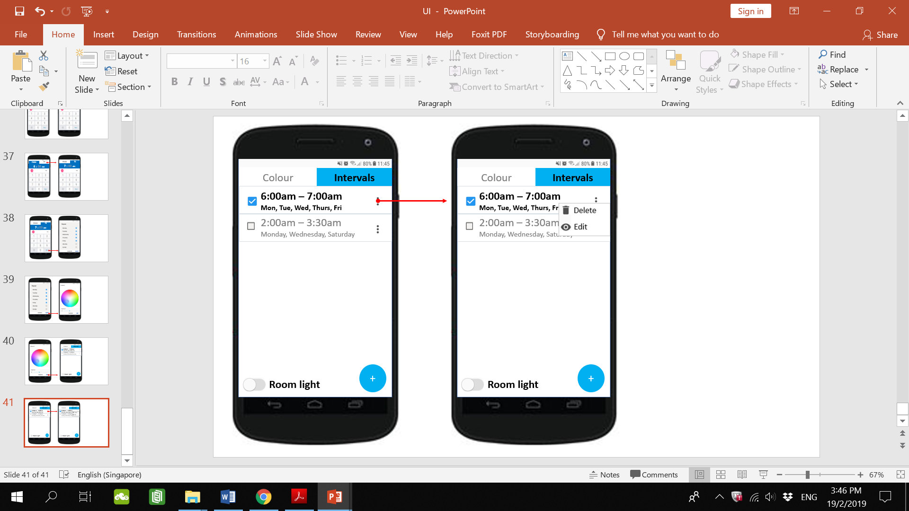

**Justification & Critique:**

Upon selecting the options button at the side of the interval a pop-up would show options to delete or edit the interval. The options button is very small and so is the pop-up with the delete and edit buttons. This would make it require more precision to select especially for someone with big fingers. The delete option deletes the interval while the edit option would direct the user back to the set interval timing page.

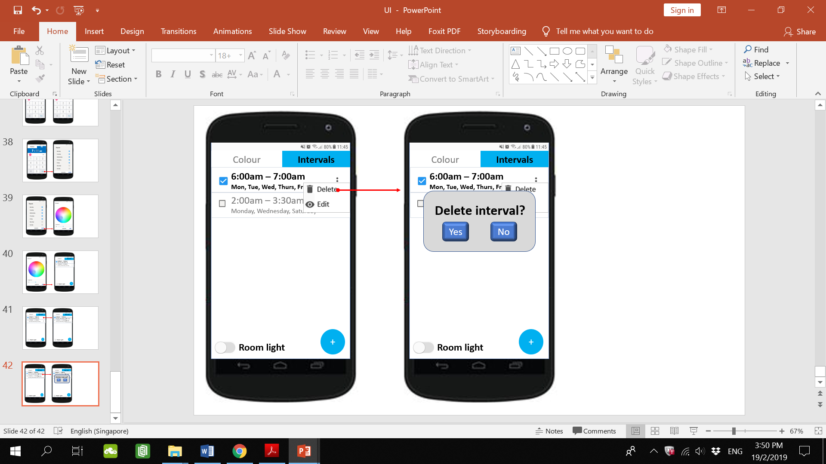

**Justification & Critique:**

If the user selects delete (left), the user will be prompted to confirm that deletion (right). This is in line with the Usability Heuristic of User control and freedom. In the case that the user mistakenly selected the delete option (left), the user is able to select No so that this mistake is easily rectified.